

Amazon Fulfillment Technology Controls Engineering

Sortable/Non-Sortable SLAM G3.0 Build Specification

Published Released – 24th June 2016

Amazon Fulfillment Technology Controls Engineering

Publication – AFTCE-CNTRL-SLAM-G3_0-V1_13-20160602

(02 June 2016 – Rev 1.13)

**Revision History**

| **Version** | **Author** | **Date** | **Content** |
| --- | --- | --- | --- |
| V 1.0 | Jay Shaver | 06/05/14 | Initial Release |
| V 1.1 | Jay Shaver | 06/18/14 | Internal Review Updates |
| V 1.2 | Jay Shaver | 06/24/14 | * Sections 3.5, 3.6, 3.7 – Remove reference of “Rabbit” controller * Section 5.2.2 – Removed outlet requirements for EU |
| V1.3 | Jay Shaver | 07/07/14 | * Section 1 Overview – updated to properly reflect the seven sections of the SLAM * Section 2.1 MTBH – added two sections to clarify the use/need for a SLAM to process polybags * Section 2.3 Orientations – included diagrams showing the two hands of a SLAM * Section 3 Mechanical Layout – added clarification regarding the “Run-in” period * Section 3.1 Alignment Conveyor – provided additional clarification regarding motion control PLC logic and updated plain view * Section 3.2 Metering Conveyor – provided additional clarification regarding motion control PLC logic and updated plain view * Section 3.3 Scale Conveyor – provided additional clarification regarding motion control PLC logic and updated plain view * Section 3.4 Buffer Conveyors – provided additional clarification regarding motion control PLC logic and updated plain view * Section 3.5 Printer Conveyors – provided additional clarification regarding motion control PLC logic and updated plain view * Section 3.6 Verify/KO Station – provided additional clarification regarding motion control PLC logic, updated plain view, and removed reference of Rabbit Controller * Section 3.7 Optional Secondary Divert – provided additional clarification regarding motion control PLC logic, updated plain view, and removed reference of Rabbit Controller * Removed the Controls Architecture section, that included subsections discussion the Supervisory Layer and Control Layer. Section was not seen relevant in providing clear scope of work required from vendor * Section 4.1 Environment – updated to reflect F temperatures * Section 4.2 Electrical – updated to include references to both NA and EU Amazon controls specifications * Section 4.3.2 Convenience Outlets – removed EU from requirements * Section 4.3.3 Main Control Cabinet Interface – added section outlining the external control panel interface outlets * Section 4.3.4 Field I/O Power – updated to indicate who provides the power * Section 4.4 Pneumatic Requirements – provided minimal requirements for both NA and EU * Section 4.6.2 Emergency Stop – updated to indicate that an estop pull-cord is required on both sides of SLAM * Added section 4.7.2 Alternative SLAM Controller optional pricing * Section 4.9.2 Applicator – combined sections to better describe applicator requirements and updated equipment part numbers for EU * Section 4.10 Touchscreen – updated to include required part numbers to build the Touchscreen terminal assembly * Section 4.11 Photo-eye – updated formatting of requirements * Section 4.13 Reader Station – updated overview to provide clearer definition as to who provides the reader stations * Section 4.13.1.1 & 4.13.1.2 Reader Stations – added in order to provide additional detail of the reader station frame structures for both the Scale and Verify * Section 4.13.3 Electrical Installation – updated drawings to properly reflect the wiring without a Rabbit controller |
| V1.4 | Jay Shaver | 07/12/14 | * Section 2.1.2 Polybag Sortable SLAM – Corrected Polypage to Polybags * Section 3 Mechanical Layout – revised run-in testing requirements * Section 3.1 Alignment Conveyor –   + Revised dry-contact to electrical isolated signals   + Added SLAM Estop Interlock (to match section 5.1.2.1 Upstream Interface Box detail.)   + Added Upstream Running Interlock (to match section 5.1.2.1)   + Removed approximately for sensor placement   + Revised Motor Control to reflect proper DC control requirements   + Removed Belt Material (roller conveyor, no belts required) * Section 3.2 Metering Conveyor –   + Removed approximately for sensor placement   + Revised Motor Control to reflect proper DC control requirements * Section 3.3 Scale Conveyor –   + Revised Purpose section for clarity   + Revised Control System Requirements:     - In System Hardware, Scale section added clarification of Scale requirements and functionality     - In Sensor section:       * Removed approximately for sensor placement       * For Scale Trigger PE, removed any references of transmitting Scale data     - In Motion Control Logic section, added Scale Control section for clarification * Section 3.4 Buffer Conveyors –   + Changed title from Conveyor(s) to Conveyors   + Revised Motor Control to reflect proper DC control requirements * Section 3.3 Printer Conveyors –   + Changed title from Conveyor(s) to Conveyors   + Revised Motor Control to reflect proper DC control requirements * Section 3.4 Verify/Kickout Station –   + Removed approximately for sensor placement   + Revised Motor Control to reflect proper DC control requirements * Section 3.5 Optional – Secondary Divert –   + Revised dry-contact to electrical isolated signals   + Added SLAM Running Interlock (to match section 5.1.2.2 Downstream Interface Box detail.)   + Removed approximately for sensor placement   + Revised Motor Control to reflect proper DC control requirements * Section 4.3 Power Source – Added clarification for both NA and EU on power source responsibilities and termination requirements * Section 4.4 Pneumatic Requirements – Added clarifications on air supply provided and connection responsibility * Section 4.5 Ethernet Drops / Connections – Added clarification as to who is providing/installing data drops * Added Section 4.8 Minimum Firmware / Software for additional clarification * Section 4.9.1 and 4.9.2 (Scale NA/EU) – corrected weighting to weighing * Section 4.10.2.2 Applicator For EU:   + Updated applicator model from 5300 to 5300 LSA, to indicate that the model should be based on the Linear Servo version   + Updated the safety requirements to requiring the use of an area safety laser scanner * Section 4.12 Photoeyes – Added built to indicate mounting adjustability * Section 4.13.1 Profiler Keyence Measuring Sensor Hardware, corrected integration to integrated, and assembly to assembled * Section 5.1.2.1 Upstream Interface Box Detail – Removed SLAM Stop Interlock (not used) * Section 5.1.2.2 Downstream Interface Box Detail:   + Added “Flat Sorter Running” to Downstream Straight interface for clarification   + Added “Shipping Sorter Running” to Downstream Diverted interface for clarification |
| V 1.5 | Jonathan Ide | 05/08/15 | * 2.1 – Changed MTBH to Metric added Wallet and option for 3mm height. * 2.3 – Added option for right justified package on LH SLAM. * 3.0 – Added note to vendor * 3.1 - Added option for vendor to specify dimensions, speed, height, motor control.   + Added safety requirement for EU. * 3.2 - Added option for vendor to specify dimensions, speed, height, motor control.   + Added safety requirement for EU. * 3.3 - Added option for vendor to specify dimensions, speed, height.   + Added safety requirement for EU.   + Added Hazmat label requirement. * 3.4 - Added option for vendor to specify dimensions, speed, height, motor control.   + Added safety requirement for EU. * 3.5 - Added option for vendor to specify dimensions, speed, height, motor control.   + Added safety requirement for EU. * 3.6 - Added option for vendor to specify dimensions, speed, height, motor control.   + Added safety requirement for EU. * 3.7 - Added option for vendor to specify dimensions, speed, height, motor control.   + Added safety requirement for EU. * 4.2.2 – Added EUCE V2.01 requirements. * 4.3.3 – Added reference to EUCE requirements.   + Added option for power meter. * 4.5 – Added EU Ethernet drop requirements * 4.7 – Added EU requirement for SLAM PLC. * 4.7.3 – Changed to separate EU/NA requirement for Module 1.   + Added inputs for Pushbuttons. * 4.8 – Cognex V5.50 firmware * 4.9.3 – EU scale requirement changes * 4.10.3.2 – Added CTM Option for EU and new servo applicator for Weber   + Replaced scanner with light curtain * 4.11 – Added EU pushbutton requirement * 4.14.3.1 – Added View Expander Option * 5.1.2.1 – Added EU DC supply * 5.1.2.2 – Added EU DC supply |
| 1.6 | Jonathan Ide | 05/08/2015 | * 3.1-3.7 – Amended safety EU requirement * 3.3 – Generalised barcode reading requirement with a 10 barcode limit. * 3.6 – Generalised barcode reading requirement with a 15 barcode limit. * 4.2.2 – Amended EUCE standards version to latest * 4.10.3.2 – Added EU/Local override for safety fencing. * 4.14 – Invited vendor to provide their own frame design |
| 1.7 | Karl Schrader | 08/28/2015 | Summary of Changes:   * Elimination of all 120VAC systems * Elimination of all field mounted DC power supplies * Elimination of all convenience outlets powered by SLAM * Elimination of Rabbit Controller, I/O remap * Addition of Rotary Tamp Kit * Addition of View Expander to Verify * Relocation of HMI station * Improved harmonization NA/EU * 3.1 – 3.7 – Updated Recommended Speeds * 3.3 – Purpose Description updated * 4.3.2 – Elimination of Convenience Outlets * 4.3.3 – Elimination of Convenience Outlet * 4.3.3 – Combined majority of NA/EU Requirements * 4.4 – Combined descriptions of Pneumatic air for NA/EU * 4.5 – Combined Ethernet Patch Panel component recommendation for NA/EU. Added language “or equivalent” * 4.6.1 – 4) modified from “or” to “and” with language addition of “as required” * 4.7.1 – 4.7.2 – Combined NA/EU I/O card definition. Replacement of 120VAC input card with 24VDC input card as first module * 4.7.3 – Added defined I/O for Rotary Tamp Kit on modules 7 and 8 * 4.8 – Changed firmware from v.5.5.0 to v.5.2.0 due to Cognex retraction of v.5.5.0 * 4.10.2 – Added network configuration for printer logical port * 4.10.3.1 – Added option request for CTM Servo Tamp for NA/EU. Removed this text from EU section * 4.11 – Location of HMI moved to Kick Out divert * 4.14.2.1 – Definition of bar codes made more generic * 4.14.2.2 – Elimination of Cognex power box. Use Cognex terminal box option w/o power supply. All 24VDC power to be sourced in main control panel * 4.14.4 – Removed language for Cognex power supply and called for individual fusing * 4.14.4 – All topology and wiring graphics updated * 5.1.1 – Sensor Box 2 updated for RTK * 5.1.2 – Updated interlock table to reflect 24VDC to dry contacts in NA/EU |
| 1.8 | Jonathan Ide | 24/09/2015 | * 4.8 – Added print engine firmware version * 4.9 – Ready for trade requirement on scale * Updated part number of Metler/Garvins scale to SL40 ICS469 scale (CWICS469-40, part#66083997) * 4.10.3.2 – Added clarification of package sensing requirement * 4.11 – Added START PB requirement * 4.14.3 – Cognex to supply BoM for EU. |
| 1.9 | Jonathan Ide | 06/10/2015 | * 4.9 – Changed to “Legal-For-Trade”. |
| 1.10 | Jonathan Ide | 23/10/2015 | Section 4:   * Added convenience outlet requirement at KO divert for EU SLAMs * Added optional programmable safety relay for EU SLAMs * Added power meter requirement * Added Light Curtain Input for EU SLAMs * Added extra Ethernet drops for EU SLAMs |
| 1.11 | Jonathan Ide | 26/10/2015 | * Added non-sortable MTBH and dimensions * Moved Cognex BoM’s to Appendix A/B/C |
| 1.12 | Karl Schrader | 13/05/2016 | Added Section 3.8 for Polybag Divert option  Section 4.5:   * Added requirement for Cisco Switch * Reduced number of network drops   Section 4.7.3   * Module 1 DC Input Card Only – NA and EU * Module 1 Removed jumper inputs 3, 4 * Module 2 Removed jumper inputs 13, 14 * Module 4 Changed to 1769-OB16 from 1769-OV16 * Module 4 Removed Tamp Triggers from outputs 0,1 * Module 4 Added Intralox divert outputs * Module 8 Added Tamp Triggers to outputs 9,11   Section 4.9.4   * Added option for vendor to recommend additional models for Weigh in Motion scale   Section 4.10.3   * Added requirement for package detect sensor   Section 4.10.3.3   * Added option for vendor to recommend additional models for label applicator   Section 4.1   * HMI hardware changed to EA9-T6CL as previous P/N is no longer available.   Section 5  Figure 14   * I/O Box locations removed   Section 5.1.1   * I/O boxes to be defined by vendor   Appendix B   * BOM expanded for 6-sided scanning at scale in EU SLAM lines |
| 1.13 | Jonathan Ide | 27/05/2016 | Section 1.1 – Added proposal conditions  Section 2.1 – Removed optional 3mm height  Section 2.4 – removed and added to mechanical layout.  Section 4 – Correct Cisco P/N  Section 4.5 – Amended drop requirements  Section 4.6.3 – Added Light Curtain Section  Section 4.7.1 – Changed output module in slot 4  Section 4.7.2 – Changed output module in slot 4  Section 4.7.3 – Added bottom trigger output (EU)  Section 4.10 – Amended printer requirements  Section 4.14.1 – Amended Cognex requirements |
| 1.14 | Karl Schrader | 24/06/2016 | Section 3.7 – Added description for divert take-away conveyor   * Updated graphic   Section 3.8 – Added description for divert take-away  Section 4.7.2 – Reverted Card #3 to 1769-OV16  Section 4.7.3 – Reverted Card #3 to 1769-OV16   * Updated all I/O to reflect Intralox Option in 2016 |

The contents of this document has been reviewed, any discrepancies or clarifications found should be brought to the authors attention, in order to be included in subsequent releases. Information within this document is subject to change without notice.

Table of Contents

1. Overview 5

1.1 Important proposal submission information 6

2. SLAM Process Requirements 7

2.1 Materials to be handled 7

2.2 Standard Sortable SLAM: 7

2.3 Polybag Sortable SLAM: 7

2.4 Orientations 7

2.3.1 Non-Sortable SLAM Layout 8

3. Mechanical layout 9

3.1. Alignment Conveyor 11

Interface Signals 11

Sensors 12

Motion Control Logic – By Amazon 12

3.2. The Metering Conveyor 13

Sensors 13

Package Present (Physical) 13

Over-Height Package (Physical) 13

Motion Control Logic – By Amazon 13

3.3. The Scale Conveyor 15

System Hardware 15

Package Profiler 15

Scale 15

Scale Reader Station (Barcode Vision Scanner) 15

Sensors 15

Scale Package Present (Physical and part of the Profiler) 15

Scale Trigger / Transfer (Physical and part of the Scale) 15

Motion Control Logic – By Amazon 16

Scale Controls (scale controller, display, load cells, etc.) – By Scale OEM 16

3.4. The Buffer Conveyors 17

Motion Control Logic – By Amazon 17

3.5 Printer Conveyors 18

System Hardware 18

Label Printer Applicator 18

Sensors 18

Transfer Photo-eye (Physical) 18

Motion Control Logic – By Amazon 18

3.6 Verify / Kickout Station 20

System Hardware 20

Verification Reader Station (Barcode Vision Scanners) 20

Interface Signals 20

Sensors 21

Transfer (Physical) 21

*Update (Physical)* 21

*KO Chute Full (Physical)* 21

Motion Control Logic – By Amazon 21

3.7 Optional - Secondary Divert (Sortable ONLY) 23

Sensors 23

*Update (Physical)* 23

Motion Control Logic – By Amazon 23

3.8 Optional – Polybag Divert Upgrade (Sortable ONLY) 24

Sensors 24

Transfer (Physical) 24

*Update 1 (Physical)* 24

*Update 2 (Physical)* 24

*KO Chute Full (Physical)* 24

Motion Control Logic – By Amazon 24

4. System Requirements 26

4.1. Environmental 26

4.2. Electrical Design / Specifications 26

4.2.1. For NA - Amazon NACE Controls Specifications: 26

4.2.2. For EU - Amazon EUCE Controls Specifications: 26

4.3. Power Sources 26

4.3.1. Primary Power Source 26

4.3.2. Convenience Outlets 27

4.3.3. Main Control Cabinet Interface Connector 27

4.3.4. Field I/O Power 27

4.4. Pneumatic Requirements 27

4.5. Ethernet Drops 28

4.6. Safety and Emergency Stop 29

4.6.1. Safety 29

4.6.2. Emergency Stop 29

4.6.3. Light Curtain (EU) 29

4.7. SLAM Controller (Allen-Bradley L33ER) 30

4.7.1. SLAM PLC Hardware (provided by Vendor) 30

4.7.2. SLAM Controller PLC Configuration 30

4.7.3. SLAM Controller I/O Layout 31

4.8. Minimum Firmware / Software versions 35

4.9. Scale 35

4.9.2. For NA: 35

4.9.3. For EU: 35

4.9.4. Additional Scale Models 35

4.10. Label Printer Applicator 36

4.10.2. Print Engine 36

4.10.3. Applicator 36

4.10.3.1. For NA 36

4.10.3.2. For EU 36

4.10.3.3. Additional Applicator Models 37

4.10.3.4. Mounting 37

4.10.3.5. Interface Connections 37

4.11. Touchscreen (HMI) Terminal 38

4.12. Photo-eyes 38

4.13. Profiler 39

4.13.2. Keyence Measuring Sensor Hardware 39

4.13.3. Keyence Measuring Sensor Hardware Part List 41

4.13.4. Electrical Installation 42

4.14. Reader Station - Cognex Vision System 43

4.14.1. Overview 43

4.14.1.1. Scale Reader Station 44

4.14.1.2. Verification Reader Station 44

4.14.2. Hardware 45

4.14.4 Electrical Installation (NA/US only) 46

5 Field Wiring / Interface Signals 50

5.1 Field Device I/O Sensor Boxes 51

5.1.1 Field Sensor I/O Boxes Connection Detail 51

5.1.2 Interface Boxes 51

5.1.2.1 Upstream Interface Box Detail 51

5.1.2.2 Downstream Interface Box Detail 52

5.2 Printer Applicator Interface Signals 53

5.3 Scale Photo-eye Interface Signals 54

APPENDIX A: Cognex reader station BOM (NA/US sortable option) 55

# Overview

The primary function of the SLAM line is to read the identifying SPOO label on a package, weigh the package, and send the weight/SPOO label data to the Warehouse Management System (WMS) to verify that the package has the correct weight. Once the weight is confirmed, a shipping label is printed and applied to the package via a Label Print and Apply unit (LPA), also called the printer assembly. Finally, the SPOO and shipping labels are scanned to confirm that the correct shipping label has been applied to the package. If the package fails any portion of the verification process it will be rejected at the kick-out line.

SLAM is comprised of seven, logical sections as shown in figure 1. Each section may have one or more conveyors.

1. **Alignment** – The alignment rollers take packages that are in various orientations, and straighten them before they enter the SLAM line.
2. **Metering** – This section has two belts; the first belt runs slower than the second to create gaps between packages, so parcels will be weighed and labeled individually.
3. **Scale** – In the Scale section, parcels are weighed, and the identification barcode (SP00, license plate) is read.
4. **Buffer** – This conveyor exists to allow time for the SLAM Host to retrieve all of the required information needed to print a shipping label and to further insure proper gapping between parcels for the labeling/verifying process.
5. **Printer** – This section indexes packages under the printer applicator so that a shipping label can be applied to a parcel. When in a dual print-apply mode, the applicators alternate in applying labels to parcels (I.E. applicator 1 applies labels on every other package.)
6. **Verification / Kick-Out:**
   1. **Verification** – At the verification section, the SP00 and shipping label are read and sent to the SLAM controller for comparison. Packages with the correct shipping label are allowed through, while those with incorrect labels are marked for kick-out.
   2. **Kick-out** – The Kick-Out section contains a sorter that is used in diverting packages that failed validation, require manual intervention, or were not properly read at the scale. Packages diverted (kick-out) are routed onto a small section of gravity conveyor.
7. **Secondary Sorter (optional)** – Packages that pass verification are indexed to the secondary sort section in where the packages are sorted based on shipping method (Package Sorter or Flat Sorter.)

Figure 1: Example Sortable SLAM Layout (not to scale, excl. guarding)

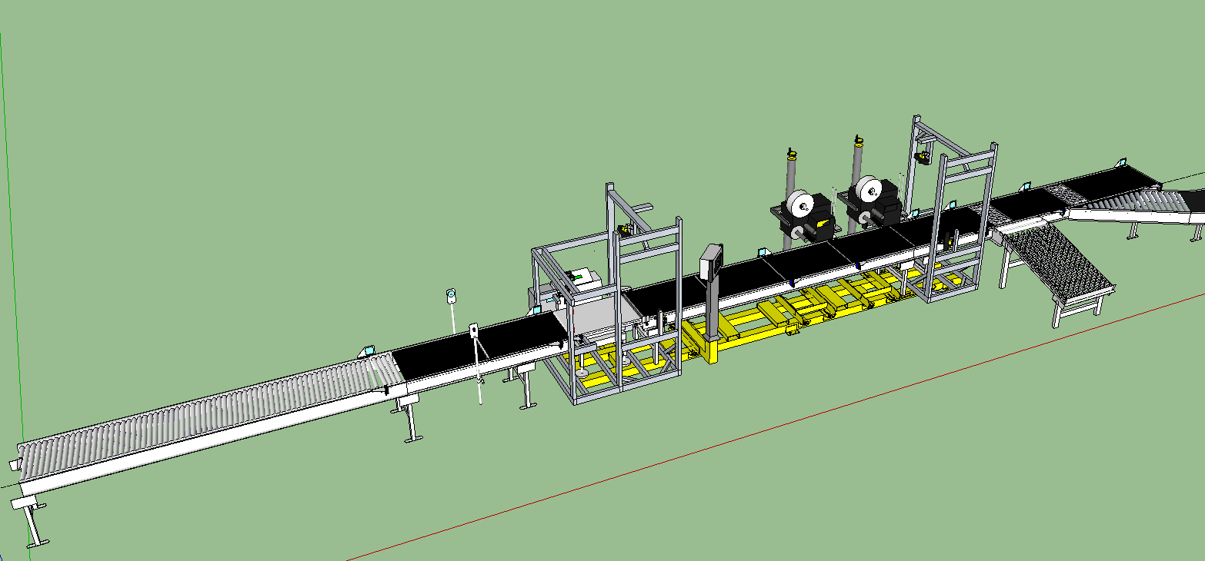

**Flow**

**Verification**

**Secondary Divert**

**KO**

**Divert**

**Kick-Out**

**Station**

**Printer**

**Buffer**

**Scale**

**Alignment**

**Metering**

# Important proposal submission information

The vendor is asked to consider a number of scale and applicator options during the proposal stage. All such options must be considered and discussed with Amazon (Procurement and Engineering) during the proposal phase such that only a single option proposal is submitted to Procurement. Amazon will not accept proposals that provide options for using different equipment, the vendor is instead requested to provide a best offer proposal that meets the requirements and that has been discussed and approved with the Project or Controls Engineer during the proposal stage.

All other options, such as sortable/non-sortable/polybag SLAM options should be quoted separately.

# SLAM Process Requirements



## Materials to be handled

A SLAM is to handle the following product range:

|  |  |  |  |  |  |  |  |  |  |
| --- | --- | --- | --- | --- | --- | --- | --- | --- | --- |
| **Material to be Handled (MTBH) – 2016 (Draft)** | | | | | | | | | |
|  | | | | | | | | | |
| **SLAM Type** | **Package Type** | **Height mm** | | **Length mm** | | **Width mm** | | **Weight**  **Kg** | |
| *Min* | *Max* | *Min* | *Max* | *Min* | *Max* | *Min* | *Max* |
| **Sortable** | Box | 5* | 460 | 170 | 720 | 120 | 460 | 0.05 | 25 |
| Poly**\*** | 314 | 610 | 238 | 485 |
| Jiffy/Wallet | 5* | 127 | 178 | 410 | 120 | 330 |
| **Non-Sortable** | Box | 75 | 460 | 230 | 1020 | 180 | 715 | 0.15 | 30 |
|  | | | | | | | | | |

* if SLAM is equipped with sort section for Poly-bags

## Standard Sortable SLAM:

A Standard Sortable SLAM is to be equipped to process and handle the following Box Suites noted in the above MTBH table:

* Box
* Jiffy-mailers (small bubble-wrapped envelopes.)
* Wallets (small unpadded envelopes.)

## Polybag Sortable SLAM:

A Polybag Sortable SLAM is an optional version of the Standard Sortable SLAM, in where the sorter sections (KO and Secondary) are replaced by a sortation system that is specifically design in the handling of polybags. A Polybag SLAM must be able to process the following Box Suites noted in the above Product to be Handle table:

* Boxes
* Jiffy-mailers
* Polybags
* Wallets (small unpadded envelopes.)

## Orientations

SLAM lines are built in two orientations – right aligned and left aligned – as seen in flow direction. The alignment is related to the “operator” side of the line. Packages are to be aligned toward the operator side. All operator devices (display, scale terminal, applicator label supply) are either located or mounted facing the operator side of the line.

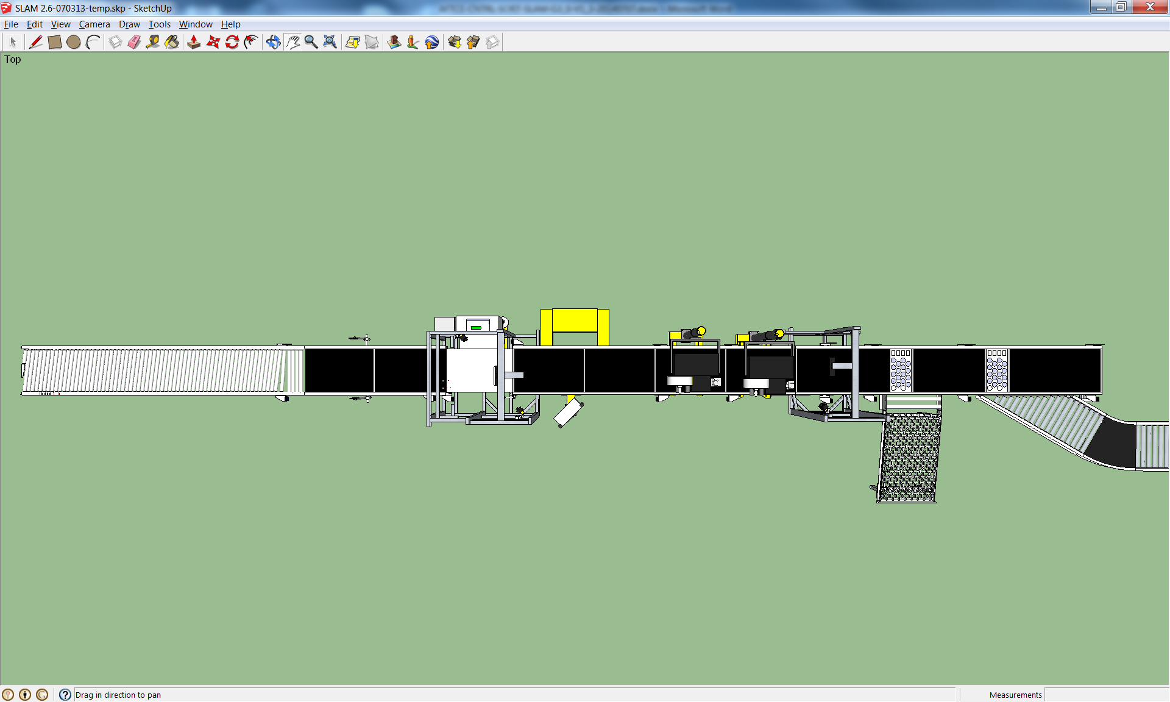

**Flow**

**Right Hand**

**Operator Side**

Figure 2: Example Sortable Right Hand SLAM Layout (not to scale)

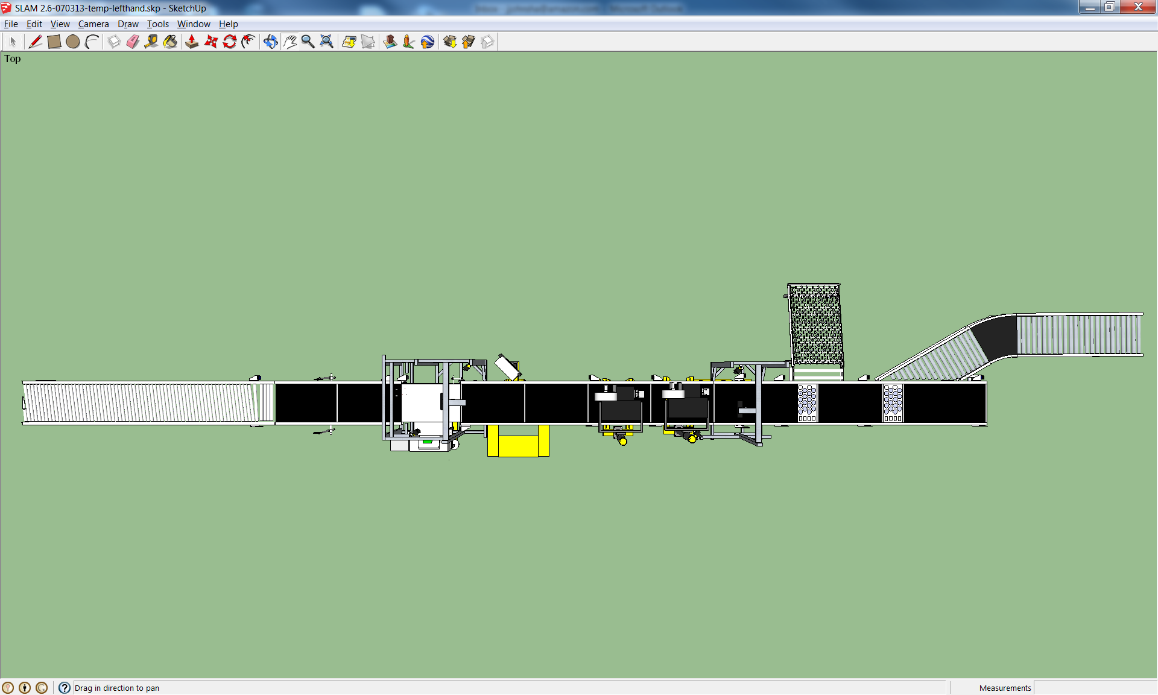

**Flow**

**Left Hand**

**Operator Side**

Figure 3: Example Sortable Left Hand SLAM Layout (not to scale)

### 2.3.1 Non-Sortable SLAM Layout

A non-sortable SLAM does not have a secondary divert and KO section is a powered roller conveyor.

# Mechanical layout

The SLAM shall be factory built such that that the SLAM can be split into modular sections (subframes) for transport to customer’s site. These subframes must be easily joinable at the customer’s site such that once the subframes are joined; there is no need for mechanical alignment of any of the conveyance.

All components of the line (especially wires and cables) must be built so that the line can be easily re-assembled at customer’s site. In the case of wires and cables, they must each have a labeled, polarized connector in the main electrical panel such that the cables can be disconnected, the line separated and shipped, and the cables re-connected at the customer site with little technical skill required.

All diverts and conveyance must divert or convey shipments across the sortable box suite at a minimum of 50 cartons per minute.



**Flow**

**HMI**

**Applicators**

**(LPA)**

**Printer**

**Profiler**

**Verify Reader**

**Station**

**Scale Reader**

**Station**

**Verification**

**Secondary Divert**

**KO**

**Divert**

**Kick-Out**

**Station**

**Buffer**

**Scale**

**Alignment**

**Metering**

Figure 4: Example Sortable SLAM Layout (not to scale)

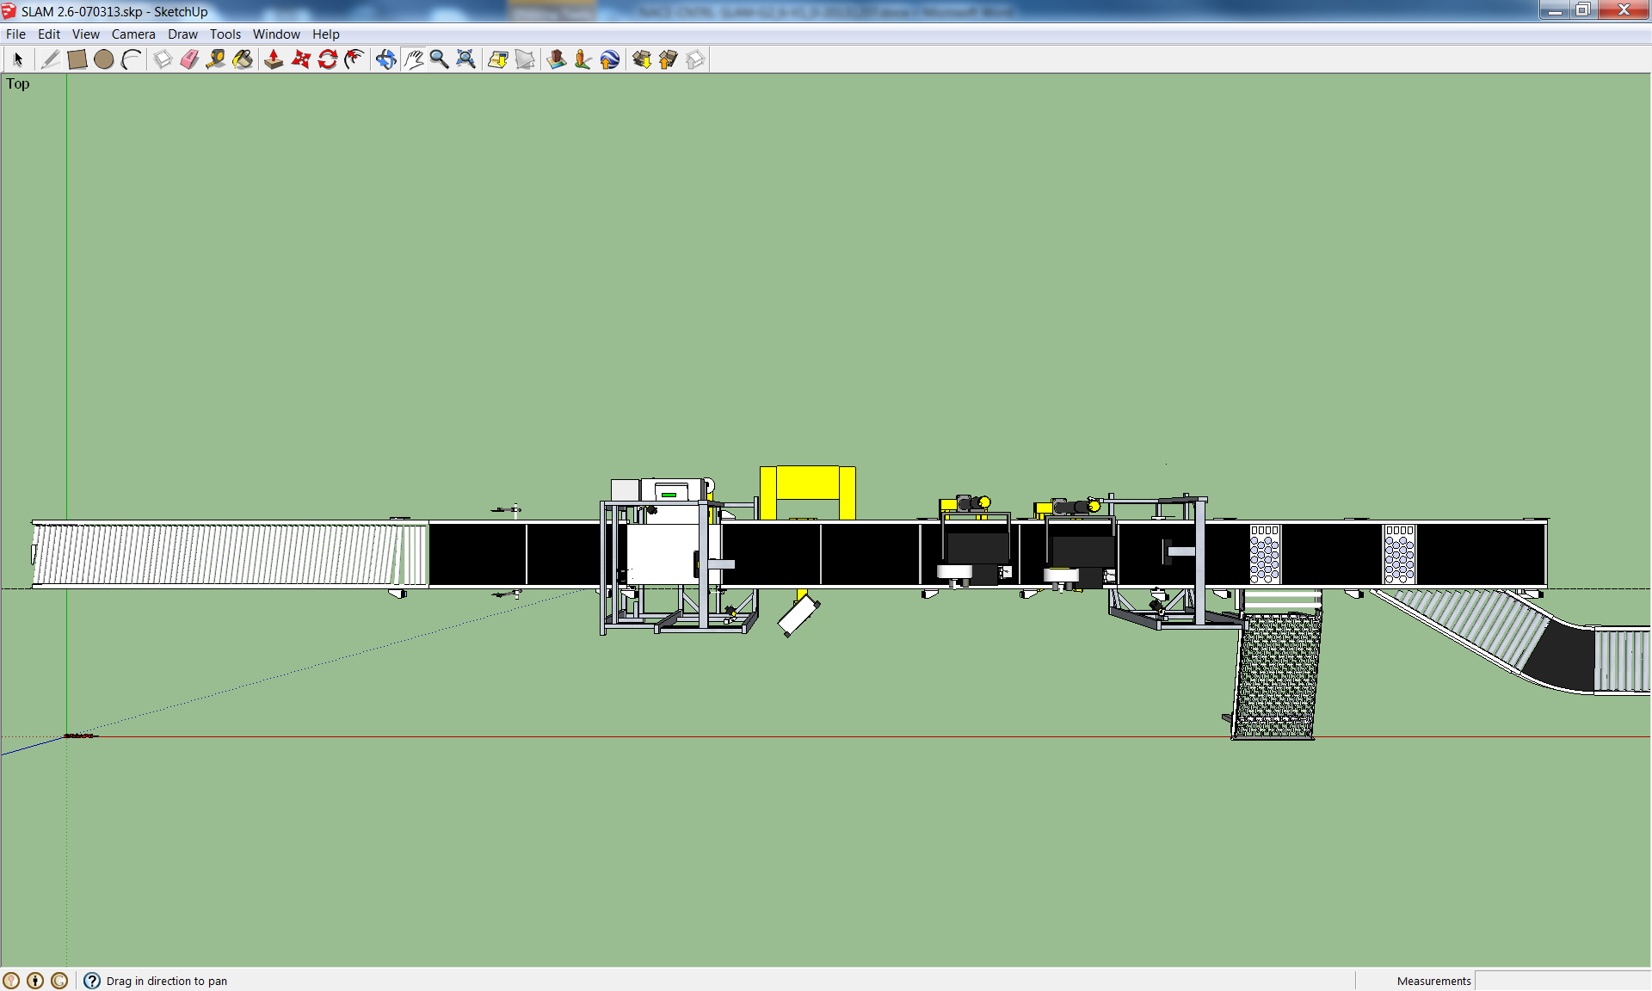

**Flow**

Figure 5: Example Sortable SLAM Top View (not to scale)

Prior to shipping to the customer’s site, each SLAM shall undergo a functional system check.  The functional system check consists of:

* Powering up the SLAM
* Validating that all components/devices properly power up
* Installing a “SLAM Functional System Check PLC” program into the SLAM PLC using a SD memory card that is pre-loaded with an Amazon provided functional system check PLC program.
* Install the “SLAM Functional System Check HMI” program into the SLAM HMI using a USB memory stick that is pre-loaded with an Amazon provided functional system check HMI application
* Activate the “System Check” application though the SLAM HMI (System Check will stay active until disabled at the HMI)
* With the “System Check” enabled, observe and verify that the following properly operate for at least five minutes:
  + All motors are indexing at the correct speed (tach) and direction
  + All Readers activated
  + Applicators properly cycle when manually advance a label from the print engine (testing of applicators can be done simultaneously with all other system checks)
  + Diverts properly cycle
* Deactivate the “System Check” after completing all checks

In the case of any failures during the system check, the failed device should be replaced and recheck prior shipping.

A copy of the system check (including any notes of failed/replace components) should be shipped with the SLAM so that can be included as part of the pre-commissioning check list and final acceptance.

The following tables describe in details the physical and operational requirements for each conveyor section of the SLAM.

**Please note that the following section invites the vendor to specify certain aspects of the design, this does not mean that the vendor's choice will be immediately accepted by Amazon. Deviations from the typical values will be internally assessed and the Amazon Controls Engineer may seek clarification from the Vendor before proceeding.**

## Alignment Conveyor

|  |  |
| --- | --- |
| Purpose | The alignment conveyor creates a row of packages that are justified either right or left edge (depending on the SLAM orientation). In order to ensure correct operation of the barcode scanners and print/apply, this section must always ensure that packages are aligned. **As per section *“2.3 Orientation”* – Vendor is invited to provide a right-hand justified only option.** |
| Dimensions  (outside to outside) | Vendor to specify. Conveyor design must align shipments according to MTBH in the directing of flow.  Typical sortable: 635mm (25”) wide, 3658mm (12’) long diagonally skewed roller conveyor  Typical non-sortable: 940mm (37”) wide, 5486mm (18’) long (diagonally roller conveyor) |
| Height  (top of belt) | Vendor to specify.  Typical Sortable: Top of belt: 762mm (30”)  Typical Non sortable: Top of belt: 711mm (28”) |
| Control system requirements | Interface Signals  * + Upstream System Estop Active – dry contact that is open when an emergency stop condition is active on the upstream conveyor system. The contact will be wired to the Upstream Interface Box (see section “*5.1.2.1 – Upstream Interface Box Detail*” for further detail.)   + SLAM Running – Electronic isolated interlock to upstream conveyor. This signal will be active (on) when the Alignment conveyor is running and deactivated (off) when the Alignment conveyor is stopped for any reason. The signal will be wired to the Upstream Interface Box (see section “*5.1.2.1 – Upstream Interface Box Detail*” for further detail.)   + SLAM Estop Active – dry contact that is open when an emergency stop condition is active on the SLAM unit. The contact will be wired to the Upstream Interface Box (see section “*5.1.2.1 – Upstream Interface Box Detail*” for further detail.)   + Upstream Running – Electronic isolated interlock from the upstream conveyor. This signal will be active (on) when the Upstream conveyor is running and deactivated (off) when the Upstream conveyor is stopped for any reason. The signal will be wired to the Upstream Interface Box (see section “*5.1.2.1 – Upstream Interface Box Detail*” for further detail.) * Package Entering System - Electronic isolated interlock from upstream conveyor. This signal will be active (on) when the upstream conveyor system detects that a package is entering onto the Alignment conveyor. When active (on), this will signal the SLAM of any incoming packages and will take the SLAM out of energy management. The SLAM will sound the warning horn for 5 seconds when restarting from energy management. The signal will be deactivated (off) when no packages are detected entering the Alignment conveyor. The signal will be wired to the Upstream Interface Box (see section “*5.1.2.1 – Upstream Interface Box Detail*” for further detail.)  Sensors Located 200mm (7-1/2”) from the discharge end of the Alignment conveyor is a physical Package Present photo-eye which is used in stopping packages at the Alignment conveyor should the downstream conveyor unit stops (Metering.) Motion Control Logic – By Amazon |
| Package handling | Diagonal rollers to align packages as they proceed across the conveyor section. The rollers must be skewed at an angle such that the narrowest package will travel from one side of the conveyor to the other in the length of the alignment section. |
| Motor control | Vendor to specify (Must be controlled via discrete I/O). Typical:   * Low Voltage DC Power Roller * DC Drive Controller:   + Adjustable speed settings via dip switch settings   + .25 second accel/decel ramps (with resistive breaking)   + Drive/Motor fault input indication to PLC controller   Lockable local motor power disconnect with PLC indication of disconnect state |
| Speed | Vendor to specify.  Typical sortable: 80 to 140 feet/minute.  Typical non-sortable: 140 feet/minute. |
| Conveyor material | Skewed Rollers |
| Construction | Vendor to specify (Typical sealed bearings, end-pulley diameter less than 100 mm, timing belt drive or direct drive). |
| Safety | Finger-safe belt transitions.  NA - E-Stop pull cord or button. With side guards.  EU – Area must be appropriately fenced, with lockable gate access, to comply with EU safety regulations and machinery directives. |
| Plan view drawing (Diagonal roller conveyor) | **Flow** |

## The Metering Conveyor

|  |  |
| --- | --- |
| Purpose | The metering conveyor is used to separate packages so that they pass the scale one at a time. In order to ensure singulation, there are two sections to the metering section and the induction section. |
| Dimensions  (outside to outside) | Vendor to specify.  Typical sortable - 635mm (25”) wide, Metering: 914mm (3’) long, Induction: 914mm (3’) long  Typical non-sortable - 940mm (37”) wide, Metering: 1219mm (4’) long, Induction: 1219mm (4’) Long |
| Height  (top of belt) | Vendor to specify.  Typical sortable: Top of belt: 762mm (30”)  Typical non sortable: Top of belt: 711mm (28”) |
| Control system requirements | SensorsPackage Present (Physical) Located 200mm (7-1/2”) from the discharge end of the Metering section is a Package Present photo-eye which is used in monitoring the gap between packages as packages index onto the downstream Scale conveyor unit.  If the gap between packages is less than that of the Scale bed length, the Metering section will stop and hold the next package detected by the Package Present photo-eye until a sufficient gap is produced that would allow only one package to index across the Scale.  Packages will also stop at the Package Present photo-eye should the downstream conveyor unit (Scale) stop. Over-Height Package (Physical) Located 1079.5mm (42.5”) from the discharge end of the Metering section (between the two sections) is an Over-Height Package photo-eye that is used in stopping the Index conveyor whenever a package is taller than then the lowest point of a Label Applicator’s. Motion Control Logic – By Amazon |
| Package handling | Mechanical separation of packages due to differential in belt speed set by gear ratio or electronically. |
| Motor control | Vendor to specify (Must be controlled via discrete I/O). Typical:   * Low Voltage DC Power Roller * DC Drive Controller:   + Adjustable speed settings via dip switch settings   + .25 second accel/decel ramps (with resistive breaking)   + Drive/Motor fault input indication to PLC controller * Lockable local motor power disconnect with PLC indication of disconnect state |
| Speed | Metering section - Vendor to specify.  Typical sortable 42.7 meters/minute (140 feet/minute)  Typical non-sortable 48.8 meters/minute (160 feet/minute)  Induction Section – Vendor to specify.  Typical sortable 48.8 meters/minute (160 feet/minute)  Typical non-sortable 54.9 meters/minute (180 feet/minute) |
| Belt material | Smooth top belt, vulcanized seam, Metering without grip, Induction with grip |
| Construction | Vendor to specify. Typical - Sealed bearings, end-pulley diameter less than 100 mm, timing belt drive or direct drive. |
| Safety | Finger-safe belt transitions.  NA - E-Stop pull cord or button. With side guards.  EU - Area must be appropriately fenced (or curtained off with a safety light curtain on operator side), to comply with EU safety regulations and machinery directives.  See section *“4.10.3.2 – Applicator for EU”* |
| Plan view drawing | **Flow** |

## The Scale Conveyor

|  |  |
| --- | --- |
| Purpose | To collect both the weight of a package and the package’s identifying barcodes    See section *“4.9 – Scale”* for details on the type of scale to be used for NA/EU. |
| Dimensions  (outside to outside) | Vendor to specify.  Typical sortable - 635mm (25”) wide, 864mm (34”) long  Typical non-sortable - 940mm (37”) wide, 1295mm (51”) long |
| Height  (top of belt) | Vendor to specify.  Typical sortable - 762mm (30”)  Typical non-sortable - Top of belt: 711mm (28”) |
| Control system requirements | System HardwarePackage Profiler The package “Profile” is determined by using a set of displacement measuring lasers and a side mounted package present photo-eye. See section “*4.13 – Profiler*” for further details. Scale The Scale is configured to measure the weight of a single package indexing across the scale and to transmit the package’s weight (in Kg) to the Scale Reader Station (via RS232) when a package is detected at the Scale Trigger/Transition photo-eye.  The Scale must have the ability of weighing a package in-motion and to continue to properly report/record the weight of the package should the package require to be stopped at the discharge end of the scale, due to downstream flow control conditions.  If more than one package is on the conveyor at a time, the combined average weight of the two packages will be transmitted to the Scale Reader Station. See section *“4.9 – Scale“* for further details. Scale Reader Station (Barcode Vision Scanner) The package’s identification barcode is scanned by using three vision cameras. The cameras are configured so that five (5) sides of a package label zones (up to 10 barcodes, code 128) are scanned (top, left, right, front, and back.) See section *“4.14 – Reader Station -* Cognex Vision System*“* for further details. SensorsScale Package Present (Physical and part of the Profiler) Located 76.2mm (3”) from the change end of the Scale conveyor and in line with the Profiler measuring lasers is the Scale Package Present photo-eye, which is used to identifying when a package indexes onto the scale. Scale Trigger / Transfer (Physical and part of the Scale) Located at the transition between the Scale and Buffer conveyors is the Scale Trigger / Transfer photo-eye. The photo-eye servers a dual purpose in: Scale Trigger The Scale Trigger is used in telling the Scale to calculate and report the weight of the package. Transfer Photo-eye (located between the Scale and the first Buffer Belt) The Transfer photo-eye is used in establishing the “True” physical location of a package. Motion Control Logic – By AmazonScale Controls (scale controller, display, load cells, etc.) – By Scale OEM |
| Package handling | None |
| Motor control | * AC motor/gearbox * AC Variable Frequency Drive Controller:   + Adjustable speed settings (via preset settings)   + .25 second accel/decel ramps (with resistive breaking)   + Drive/Motor fault input indication to PLC controller * Lockable local motor power disconnect with PLC indication of disconnect state |
| Speed | Vendor to specify.  Typical sortable - 48.8 meters/minute (160 feet/minute)  Typical non-sortable - 54.9 meters/minute (180 feet/minute) |
| Belt material | Smooth top belt, vulcanized seam, with grip |
| Construction | Sealed bearings, end-pulley diameter less than 100 mm, timing belt drive or direct drive. |
| Safety | E-Stop. Finger-safe belt transitions.  EU - Area must be appropriately fenced (or curtained off with a safety light curtain on operator side), to comply with EU safety regulations and machinery directives.  See section *“4.10.3.2 – Applicator for EU”* |
| Plan view drawing | **Flow** |

## The Buffer Conveyors

|  |  |
| --- | --- |
| Purpose | The buffer conveyor is necessary because of data latency from the WMS system that produces the shipping label and downloads it to the printer. In SLAM implementations with print-on-the-fly (such as dual print/apply SLAMs) there shall be two identical consecutive buffer conveyors.  **NOTE: Two (2) Buffer Conveyors are required for a dual print apply design.** |
| Dimensions  (outside to outside) | Vendor to specify.  Typical sortable - 635mm (25”) wide, Belt 1: 914mm (3’) long, Belt 2: 914mm (3’) long  Typical non-sortable - 940mm (37”) wide, Belt 1: 1219mm (4’) long, Belt 2: 1219mm (4’) long |
| Height  (top of belt) | Vendor to specify.  Typical sortable - 762mm (30”).  Typical non sortable: Top of belt: 711mm (28”) |
| Control system requirements | Motion Control Logic – By Amazon |
| Motor control | Vendor to specify (Must be controlled via discrete I/O). Typical:   * Low Voltage DC Power Roller * DC Drive Controller:   + Adjustable speed settings via dip switch settings   + .25 second accel/decel ramps (with resistive breaking)   + Drive/Motor fault input indication to PLC controller * Lockable local motor power disconnect with PLC indication of disconnect state |
| Speed | Vendor to specify.  Typical sortable - 48.8 meters/minute (160 feet/minute)  Typical non-sortable - 54.9 meters/minute (180 feet/minute) |
| Belt material | Smooth top belt, vulcanized seam, with grip |
| Construction | Vendor to specify. Typical - Sealed bearings, end-pulley diameter less than 100 mm, timing belt drive or direct drive. |
| Safety | E-Stop. Finger-safe belt transitions.  EU - Area must be appropriately fenced (or curtained off with a safety light curtain on operator side), to comply with EU safety regulations and machinery directives.  See section *“4.10.3.2 – Applicator for EU”* |
| Plan view drawing | **Flow** |

## 3.5 Printer Conveyors

|  |  |
| --- | --- |
| Purpose | The Printer conveyors are used in indexing package under the printing pad so that a label can be applied.  Dual-print/apply SLAM lines shall have two consecutive printer conveyor segments. The SLAM PLC will decide to either stop the package, apply the label and then release the package; or assert the package release signal to keep the package in motion and apply the label “on the fly”. |
| Dimensions  (outside to outside) | Vendor to specify.  Typical sortable - 635mm (25”) wide, Belt 1: 914mm (3’) long, Belt 2: 914mm (3’) long  Typical non-sortable - 940mm (37”) wide, Belt 1: 1219mm (4’) long, Belt 2: 1219mm (4’) long |
| Height  (top of belt) | Vendor to specify.  Typical sortable - Top of belt: 762mm (30”)  Typical non-sortable: Top of belt: 711mm (28”) |
| Control system requirements | System HardwareLabel Printer Applicator The Label Printer Applicator prints and applies a shipping label to a package.  When in a dual print-apply mode, the applicators alternate in applying labels to parcels (I.E. applicator 1 applies labels on every other package.) SensorsTransfer Photo-eye (Physical) Located between the Buffer and Printer conveyor is a Transfer photo-eye.  The Transfer photo-eye is used in establishing the “True” physical location of a package. Motion Control Logic – By Amazon |
| Package handling | None |
| Motor control | Vendor to specify (Must be controlled via discrete I/O). Typical:   * Low Voltage DC Power Roller * DC Drive Controller:   + Adjustable speed settings via dip switch settings   + .25 second accel/decel ramps (with resistive breaking)   + Drive/Motor fault input indication to PLC controller * Lockable local motor power disconnect with PLC indication of disconnect state |
| Speed | Vendor to specify.  Typical sortable - 48.8 meters/minute (160 feet/minute)  Typical non-sortable - 54.9 meters/minute (180 feet/minute) |
| Belt material | Smooth top belt, vulcanized seam, with grip |
| Construction | Vendor to specify. Typical - Sealed bearings, end-pulley diameter less than 100 mm, timing belt drive or direct drive. |
| Safety | E-Stop. Finger-safe belt transitions. With side guards.  EU - To comply with EU safety regulations and machinery directives in where a safe distance is required in protecting individuals from moving parts, this area must be protected by the light curtain on the operator side. The distance from the light curtain to the hazard must be calculated according to relevant safety standards. Amazon must be presented with the calculations upon request. On the reverse side of the SLAM the area must be in a fenced environment (extending from scale). See section *“4.10.3.2 – Applicator for EU”* |
| Plan view drawing | **Flow** |

## 3.6 Verify / Kickout Station

|  |  |
| --- | --- |
| Purpose | The Verify conveyor is used for indexing packages under the verification scanners, which scan for a packages barcodes. They are sent to the SLAM PLC to determine if the correct shipping label was applied to the correct package. If so, the package is permitted to convey to a shipping sorter, otherwise the package is Kicked-Out, for manual processing.  The Kickout conveyor is a divert section that is used to remove packages from the line that have issues such as incorrect weight or bad barcodes scans. Part of the Kickout conveyor for sortable SLAMs only is the reject chute which is a 900mm wide, 1200mm long skate-wheel conveyor used to accumulate packages (or vendor specific conveyor design). Angle of reject chute shall be steep enough such that the smallest and/or lightest package is able to roll to the end. For non-sortable SLAMs the kickout section is a powered roller conveyor. |
| Dimensions  (outside to outside) | Vendor to specify.  Typical sortable - 635mm (25”) wide, Verify: 1219mm (4’) long, Kickout: 1291mm (4’) long  Typical non-sortable - 940mm (37”) wide, Verify: 1524mm (5’) long, Kickout: 2438mm (8’) long |
| Height  (top of belt) | Vendor to specify.  Typical sortable: Top of belt: 762mm (30”)  Typical non-sortable: Top of belt: 711mm (28”) |
| Control system requirements | System HardwareVerification Reader Station (Barcode Vision Scanners) The package’s identification barcode and shipping label is scanned by using three vision cameras. The cameras are configured so that five (5) sides of a package label zones are scanned (top, left, right, front, and back up to 15 code 128 barcodes in total.) Reference section *“4.14 – Reader Station -* Cognex Vision System*“* for further details. Interface Signals  * + Downstream System Estop Active – dry contact that is open when an emergency stop condition is active on the downstream conveyor system. The contact will be wired to the Downstream Interface Box (see section “*5.1.2.2 – Downstream Interface Box Detail*” for further detail.)   + SLAM Running – Electronic isolated interlock to downstream conveyor control system. This signal will be active (on) when the SLAM is running and deactivated (off) when the SLAM is stopped for any reason. The signal will be wired to the Downstream Interface Box (see section ““*5.1.2.2 – Downstream Interface Box Detail*” for further detail.)   + “Shipping Sorter Running” (downstream divert on sortable SLAMs/not used on non-sortable SLAMs) – Electronic isolated interlock from the downstream conveyor control system. This signal will be active (on) when the associated downstream divert conveyor (divert destination) is running and able to accept packages and deactivated (off) when the associated downstream divert conveyor stopped for any reason. The signal will be wired to the Downstream Interface Box (see section “*5.1.2.2 – Downstream Interface Box Detail*” for further detail.)   + “Flat Sorter Running” (downstream straight)- Electronic isolated interlock from downstream conveyor control system. This signal will be active (on) when the associated downstream straight conveyor (non-diverted destination) is running and able to accept packages and deactivate (off) when the associated downstream divert conveyor stopped for any reason. The signal will be wired to the Downstream Interface Box (see section “*5.1.2.2 – Downstream Interface Box Detail*” for further detail.)   + “KO Chute Full” (Optional external input for non-sortable SLAM) - Electronic isolated interlock from downstream conveyor control system. This signal will be active (on) when the associated downstream KO conveyor (diverted destination) is running and able to accept packages and deactivate (off) when the associated downstream KO divert conveyor stopped for any reason. The signal will be wired to the Downstream Interface Box.  SensorsTransfer (Physical) Located at the transition between Printer 2 and the Verification conveyors is a Transfer photo-eye. *Update (Physical)* Located 152mm (6”) from the charge end of the Kick-Out divert is an Update photo-eye. The Update photo-eye is used in track packages prior to the Kick-out divert to determine if the divert is to be activated. *KO Chute Full (Physical)* Located at the transfer of the KO chute is a photo-eye that checks to see if the chute is full. The SLAM will continue to KO packages to the KO chute as long as the photo-eye is not detecting the chute full, once the chute is detected full, the SLAM stops and resumes once the eye is cleared for a set time (after sounding the 5 second warning horn.) Motion Control Logic – By Amazon |
| Package handling | Kick out packages as directed by the SLAM PLC. |
| Motor control | Vendor to specify (Must be controlled via discrete I/O). Typical:   * Low Voltage DC Power Roller * DC Drive Controller:   + Adjustable speed settings via dip switch settings   + .25 second accel/decel ramps (with resistive breaking)   + Drive/Motor fault input indication to PLC controller * Lockable local motor power disconnect with PLC indication of disconnect state |
| Speed | Vendor to specify.  Typical sortable - 48.8 meters/minute (160 feet/minute)  Typical non-sortable - 54.9 meters/minute (180 feet/minute) |
| Belt material | None |
| Construction | Vendor to specify. Typical - Sealed bearings, end-pulley diameter less than 100 mm, timing belt drive or direct drive. |
| Safety | E-Stop. Finger-safe belt transitions. Side guards on non-transfer side.  EU - Area must be appropriately fenced (or curtained off with a safety light curtain on operator side), to comply with EU safety regulations and machinery directives.  See section *“4.10.3.2 – Applicator for EU”* |
| Plan view drawing | **Flow** |

## 3.7 Optional - Secondary Divert (Sortable ONLY)

|  |  |
| --- | --- |
| Purpose | The secondary divert is an optional sort stage placed after the kickout/reject divert. This secondary divert may be used to pre-sort good shipments based on a control signal from the SLAM PLC. |
| Dimensions  (outside to outside) | Vendor to specify. Typical –  Straight Ahead Conveyor: 635mm (25”) wide, 1524mm (5’) long  Diverted Conveyor: 635mm (25”) wide, 1524mm (5’) long  Diverted Conveyor Curve: Return travel of packages parallel with SLAM |
| Height  (top of belt) | Vendor to specify. Typical - 762mm (30”). |
| Control system requirements | Sensors*Update 1 (Physical)* Located 152mm (6”) from the end of the straight take-away conveyor *Update 2 (Physical)* Located 152mm (6”) from the end of the angled take-away conveyor Motion Control Logic – By Amazon |
| Motor control | Vendor to specify (Must be controlled via discrete I/O). Typical:   * Low Voltage DC Power Roller * DC Drive Controller:   + Adjustable speed settings via dip switch settings   + .25 second accel/decel ramps (with resistive breaking)   + Drive/Motor fault input indication to PLC controller * Lockable local motor power disconnect with PLC indication of disconnect state |
| Speed | Vendor to specify. Typical - 48.8 meters/minute (160 feet/minute) |
| Construction | Sealed bearings, end-pulley diameter less than 100 mm, timing belt drive or direct drive. |
| Safety | E-Stop. Finger-safe belt transitions. Side guards on non-transfer side.  EU - To comply with EU safety regulations and machinery directives in where a safe distances is required in protecting individuals from moving parts, this area must be in a fenced environment, with easy access (quick to remove fencing or gate access). |
| Plan view drawing | **Flow** |



## 3.8 Optional – Polybag Divert Upgrade (Sortable ONLY)

|  |  |
| --- | --- |
| Purpose | The polybag divert upgrade is an optional replacement of the kickout and secondary divert mechanisms with a single section of conveyance containing two divert mechanisms. This upgraded divert mechanism is a requirement for SLAM lines processing polybag packaging. |
| OEM / Part Number | Intralox / SPL1600021(Right Hand) or SPL1600022(Left Hand) |
| Dimensions  (outside to outside) | Vendor to specify. Typical –  Straight Ahead Conveyor: OEM specified.  Diverted Conveyor: 635mm (25”) wide, 1524mm (5’) long  Diverted Conveyor Curve: Return travel of packages parallel with SLAM |
| Height  (top of belt) | Vendor to specify. Typical - 762mm (30”). |
| Control system requirements | SensorsTransfer (Physical) Located at the transition between Printer 2 and the Verification conveyors is a Transfer photo-eye. *Update 1 (Physical)* Located 152mm (6”) from the charge end of the Kick-Out divert is an Update photo-eye. The Update photo-eye is used in track packages prior to the Kick-out divert to determine if the divert is to be activated. *Update 2 (Physical)* Located 152mm (6”) from the charge end of the Secondary divert is an Update photo-eye. The Update photo-eye is used in track packages prior to the Kick-out divert to determine if the divert is to be activated. *KO Chute Full (Physical)* Located at the transfer of the KO chute is a photo-eye that checks to see if the chute is full. The SLAM will continue to KO packages to the KO chute as long as the photo-eye is not detecting the chute full, once the chute is detected full, the SLAM stops and resumes once the eye is cleared for a set time (after sounding the 5 second warning horn.) Motion Control Logic – By Amazon |
| Package handling | Pre-sort packages as directed by the SLAM PLC. |
| Motor control | OEM Specified |
| Speed | Vendor to specify. Typical - 48.8 meters/minute (160 feet/minute) |
| Safety | E-Stop. Finger-safe belt transitions. Side guards on non-transfer side.  EU - To comply with EU safety regulations and machinery directives in where a safe distances is required in protecting individuals from moving parts, this area must be in a fenced environment, with easy access (quick to remove fencing or gate access). |
| Plan view drawing |  |

# System Requirements

## Environmental

Environmental conditions at Amazon facilities are as follows:

* Temperature: +5°C (41°F) to +30°C (86°F)
* Humidity: max. 90%, non-condensing

## Electrical Design / Specifications

All power systems and wiring will be built to applicable country standards and adhere to:

## For NA - Amazon NACE Controls Specifications:

* NACE Publication – NACE-CNTRL-SPEC-R012-082113

## For EU - Amazon EUCE Controls Specifications:

* Amazon EUCE – Standards and Requirements (latest as of publication is V2.02).

## Power Sources

## Primary Power Source

* For NA:

The primary power for a SLAM is delivered by connecting a 3 Phase, 480 Volt, 60Hz, 30 Amp power feed (provided by others) to an external lockable J-type fused disconnect (provided by vendor) that is connected to the SLAM main control enclosure.

The SLAM Main control enclosure door(s) shall be interlocked so that they cannot be opened without first disconnecting the main power supply at the external disconnect. The interlock should provide a “Defeater” for authorized personnel to perform maintenance and troubleshooting while the main power feed is energized.

For the SLAM Main control enclosure, a secondary though-the-door-handle fused disconnect is not required, the external disconnect shall serve as the primary source of protection.

* For EU:

The primary power for a SLAM is delivered by connecting a 3 Phase, 400 Volt, 50Hz, 30 Amp power feed (provided by others) to the SLAM Main control enclosure through-the-door-handled disconnect (provided by vendor.)

If an integrated Circuit Breaker / Disconnect is used, the circuit breaker is to have RCB rating.

## Convenience Outlets

For EU SLAMs there is to be a convenience outlet at the KO divert (on the downstream end of the KO conveyor side). Convenience outlet is to be supplied as per section 5.5.1 “Workstations” in EUCE Standards and Requirements.

## Main Control Cabinet Interface Connector

One external side mount Panel Interface Connector is to be provided for powering a PC Laptop during debugging efforts of a SLAM. The Panel Interface Connector should be comprised of:

* + 2x RJ45 Ethernet jack (Jacks must be CLEARY marked so as to know the difference between to two ports):
    - To coupler for VendorNet programming.
    - To Cisco Switch Port 16 for private fieldbus network.
  + For EU:
    - Refer to section 2.2.4.3 Power Outlet of the EUCE – Standards and Requirements document for detailed requirements:
      * Power outlet (rated at 2amps)
    - Vendor is to provide device for measuring power consumption:
      * 1x 1420 Power Meter 500 (1420-V2-ENT).
      * 3x Current Transformer (1411-2DRL-500).
      * RJ45 cable to Cisco Switch.

## Field I/O Power

Vendor is to provide all 24Vdc power to external field devices.

## Pneumatic Requirements

The pneumatic supply for a SLAM is delivered by connecting to a 100PSI (7Bar), clean, dry, and oil-less pneumatic supply line (provided by others) to a filter / manifold assembly (provided by vendor) that distributes the pneumatic supply to the various SLAM pneumatic components.

## Ethernet Drops

The following Ethernet based control devices are to be connected to the Amazon network by an Amazon IT approved patch cable to a designated Amazon RJ-45 data port jack to be installed*/provided by Amazon, Final connection between devices and data jacks is to be coordinated and completed by Amazon Local IT. Vendor is to install an RJ45 port coupler (Wiedmuller PN – 89469200000 or equivalent). All RJ45 connections (external + internal) are to be routed to a single point inside the main electrical cabinet and connected to the mounted RJ45 couplers according to the table below. Furthermore RJ45 couplers are to be mounted such that they are all grouped together for easy wiring/access to by Amazon IT, preferably on the lower left side of the cabinet, away from the HV power inlet. All industrial equipment will be connected to the local Cisco Switch, which will be installed in the main cabinet.

|  |  |  |
| --- | --- | --- |
| **Device** | **Device Location to SLAM Control Cabinet** | **SLAM Coupler (Wiedmuller)** |
| Industrial Network Connection (Cisco Switch) | Inside | 1 |
| Printer 1 | Outside | 2 |
| Printer 2 | Outside | 3 |
| VendorNet link to front panel | Inside | 4 |

A 16 port Cisco Switch with Enhanced LAN Base License (IE-2000-16TC-G-N) must be installed in the cabinet and all field bus components are to be connected to it as per below. Amazon has pre-negotiate pricing on this component through CDW.



## Safety and Emergency Stop

## Safety

Safety of associates in Amazon.com facilities is a top priority. All conveyor designs must include safety features to help prevent personal injury. These items include, but are not limited to:

1. Integral finger guards at belt transitions – do not use transition rollers
2. Lockable motor disconnect switches with input back to SLAM PLC
3. Rounding of all corners, deburring of cuts
4. Emergency stop pushbuttons and pull-cords, as required
5. Package handling that minimizes human interaction with the conveyor
6. Appropriate use of safety interlock devices (i.e. gate interlocks)

## Emergency Stop

In the case of an emergency situation on the SLAM lines, there must be an emergency stop pull-cord (or pushbutton if guarding is used around SLAM) within a reachable distance of an operator (on both sides of the SLAM unit.) In the case of an emergency stop all conveyors and actuators must stop immediately while disconnecting the power supply mechanically from the conveyors and actuators. Also, there must be an air dump valve installed in the E-stop circuit such that all pneumatics in the SLAM line lose pressure.

The emergency stop circuit must have provisions to interlock with external cells. There must be a removable jumper in the SLAM emergency stop circuit that can be used to feed an external e-stop signal into the SLAM cell. There also must be a spare dry contact provided for interlocking the SLAM E-Stop with external equipment.

For EU the emergency stop circuit and safety devices shall comply with EU regulations.

## Light Curtain (EU)

Although the light curtain is recognized as a safety device for the applicators, it must, in addition to stopping the applicators & cutting air supply, stop the SLAM through the SLAM safety circuit. Furthermore, the activation/interruption of the light curtain must be detectable via an auxiliary contact to the PLC input on module 1.

## SLAM Controller (Allen-Bradley L33ER)

Vendor shall provide a control enclosure that contains all electrical hardware required for the control of the SLAM system (I.E. fuses, circuit breakers, contactors, relays, terminal blocks, SLAM PLC, I/O, etc.) Care must be taken in constructing the panel to isolate low-voltage components from high-voltage components and frequency convertors.

## 4.7.1. SLAM PLC Hardware (provided by Vendor)

The SLAM PLC shall be comprised of the following components:

|  |  |  |  |  |
| --- | --- | --- | --- | --- |
| **No.** | **Qty** | **Manufacture** | **Description** | **MFG Part Number** |
| 1 | 1 | Allen-Bradley | CompactLogix 2 MB ME | 1769-L33ER |
| 2 | 1 | Allen-Bradley | CompactLogix Power Supply | 1769-PA2 |
| 3 | 1 | Allen-Bradley | CompactLogix End Cap | 1769-ECR |
| 4 | 5 | Allen-Bradley | Compact I/O – 24VDC Sinking/Sourcing Input Module – 16pt | 1769-IQ16 |
| 5 | 3 | Allen-Bradley | Compact I/O – 24VDC Sourcing Output Module – 16pt | 1769-OB16 |

## SLAM Controller PLC Configuration

The SLAM Controller PLC shall be configured in accordance to the following layout:

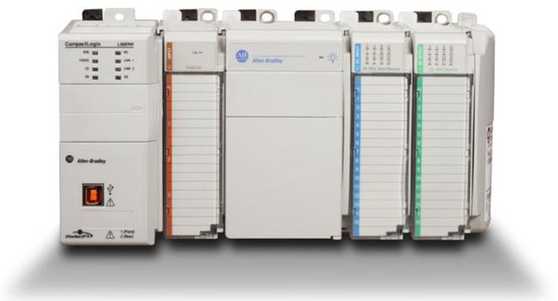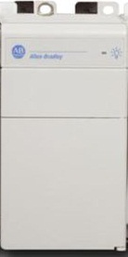

1769-ECR

1769-IQ16

1769-IQ16

1769-IQ16

1769-OV16

1769-PA2

1769-L33ER

1769-OB16

1769-IQ16

1769-OB16

1769-IQ16

## SLAM Controller I/O Layout

The following I/O layout maintains compatibility with the Amazon SLAM PLC software:

|  |  |  |  |
| --- | --- | --- | --- |
| **Module** | **I/O Point** | **Associated Unit** | **Description** |
| **Module 1 – 1769-IQ16**  **(DC Sink/Source Inputs)** | 0 | Main Control Panel | E-Stop Pushbutton |
| 1 | Printer 1 Belt | E-Stop Pull Cord (or Push Button) Switch 1 (on KO side) |
| 2 | Printer 1 Belt | E-Stop Pull Cord (or Push Button) Switch 2 (opposite of KO side) |
| 3 |  | Spare |
| 4 |  | Spare |
| 5 | Scale Belt | VFD Disconnect |
| 6 | Light Curtain Interrupt | Light Curtain Active (EU only) |
| 7 | Upstream System | External E-Stop Interlock |
| 8 | Upstream System | External Stop Request Interlock |
| 9 | Upstream System | Upstream Conveyor Running Interlock |
| 10 | Upstream System | Package Entering SLAM Interlock |
| 11 | Downstream System | Straight Downstream Conveyors Running Interlock (after 2nd divert) |
| 12 | Downstream System | Diverted Downstream Conveyors Running Interlock (after 2nd divert) |
| 13 |  | Spare |
| 14 |  | Spare |
| 15 |  | Spare |

|  |  |  |  |
| --- | --- | --- | --- |
| **Module** | **I/O Point** | **Associated Unit** | **Description** |
| **Module 2 – 1769-IQ16**  **(DC Sink/Source Inputs)** | 0 | Main Control Panel | Local E-Stop Relay (energized when no active E-Stops) |
| 1 | Main Control Panel | Master E-Stop Relay (energized when no active E-Stops) |
| 2 | Main Control Panel | Power Tap Branch Contactor (energized when active) |
| 3 | Scale Belt | VFD Contactor Active |
| 4 | (Intralox Option) | Intralox VFD is Running |
| 5 | Main Control Panel | Air Pressure OK (energized when OK) |
| 6 | Meter Belt 1 | Package Present Photo-eye |
| 7 | Meter Belt 1 | Over Height Photo-eye |
| 8 | Meter Belt 2 | Package Present Photo-eye |
| 9 | Scale Belt | Scale / Buffer 1 Belt Transfer Photo-eye |
| 10 | Flat Detect(US Only)  START (EU Only) | Tall package detected on flat sort take away (US Only)  Pushbutton Switch at HMI to start SLAM (EU Only) |
| 11 | STOP (EU Only) | Pushbutton Switch at HMI to stop SLAM (EU Only) |
| 12 | RESET (EU Only) | Pushbutton Switch at HMI to stop SLAM (EU Only) |
| 13 |  | Spare |
| 14 |  | Spare |
| 15 | Main Control Panel | DC Power ON |

|  |  |  |  |
| --- | --- | --- | --- |
| **Module** | **I/O Point** | **Associated Unit** | **Description** |
| **Module 3 – 1769-IQ16**  **(DC Sink/Source Inputs)** | 0 | Printer Belt 1 | Applicator 1 Faulted |
| 1 | Printer Belt 1 | Applicator 1 Vacuum (has label) |
| 2 | Printer Belt 1 | Applicator 1 Printing Label |
| 3 | Printer Belt 1 | Applicator 1 Label Stock Low |
| 4 | Printer Belt 2 | Applicator 2 Faulted |
| 5 | Printer Belt 2 | Applicator 2 Vacuum (has label) |
| 6 | Printer Belt 2 | Applicator 2 Printing Label |
| 7 | Printer Belt 2 | Applicator 2 Label Stock Low |
| 8 | Printer Belt 1 | Applicator 1 Tamp Solenoid is Active |
| 9 | Printer Belt 2 | Applicator 2 Tamp Solenoid is Active |
| 10 |  | Spare |
| 11 |  | Spare |
| 12 |  | Spare |
| 13 |  | Spare |
| 14 |  | Spare |
| 15 |  | Spare |

|  |  |  |  |
| --- | --- | --- | --- |
| **Module** | **I/O Point** | **Associated Unit** | **Description** |
| **Module 4 – 1769-OV16**  **(DC Sinking Outputs)** | 0 | Printer Belt 1 | Applicator 1 Apply Label Trigger |
| 1 | Printer Belt 2 | Applicator 2 Apply Label Trigger |
| 2 |  | Spare |
| 3 |  | Spare |
| 4 |  | Spare |
| 5 |  | Spare |
| 6 |  | Spare |
| 7 | Rotary Tamp Kit | Applicator 1 Rotate |
| 8 |  | Spare |
| 9 |  | Spare |
| 10 |  | Spare |
| 11 |  | Spare |
| 12 | Rotary Tamp Kit | Applicator 2 Rotate |
| 13 | Main Control Panel  (Intralox Option) | OK to Receive Interlock to Upstream (Intralox Option) |
| 14 | Main Control Panel  (Intralox Option) | Alarm Horn (Intralox Option) |
| 15 | Main Control Panel  (Intralox Option) | Fault Beacon (Intralox Option) |

|  |  |  |  |
| --- | --- | --- | --- |
| **Module** | **I/O Point** | **Associated Unit** | **Description** |
| **Module 5 – 1769-IQ16**  **(DC Sinking/Sourcing Inputs)** | 0 | Alignment Bed | Alignment Conveyor is Running |
| 1 | Metering Belt 1 | Metering Belt 1 Conveyor is Running |
| 2 | Metering Belt 2 | Metering Belt 2 Conveyor is Running |
| 3 | Scale Belt | Scale VFD is Running |
| 4 | Buffer Belt 1 | Buffer Belt 1 Conveyor is Running |
| 5 | Buffer Belt 2 | Buffer Belt 2 Conveyor is Running |
| 6 | Printer Belt 1 | Printer Belt 1 Conveyor is Running |
| 7 | Printer Belt 2 | Printer Belt 2 Conveyor is Running |
| 8 | Verify Belt | Verify Induct Belt Conveyor is Running |
| 9 | Divert 1 Belt  (non-Intralox) | Divert 1 Belt Conveyor is Running (divert 1 is running) |
| Spare  (Intralox Option) | Spare |
| 10 | Divert 1 Takeaway | Divert 1 Takeaway Conveyor is Running |
| 11 | Sorter 1 Belt | Sorter 1 Belt Conveyor is Running |
| 12 | Divert 2 Belt  (non-Intralox) | Divert 2 Belt Conveyor is Running (divert 2 is running) |
| Spare  (Intralox Option) | Spare |
| 13 | Divert 2 Takeaway | Divert 2 Takeaway Conveyor is Running |
| 14 | Sorter 2 Belt  (non-Intralox) | Sorter 2 Belt Conveyor is Running |
| Take Away Roller 3  (Intralox Option) | Take Away Motor 3 is Running |
| 15 | Divert 2 Chute | Divert 2 Chute Motor is Running |

|  |  |  |  |
| --- | --- | --- | --- |
| **Module** | **I/O Point** | **Associated Unit** | **Description** |
| **Module 6 – 1769-OB16**  **(DC Sourcing Outputs)** | 0 | Alignment Bed | Run Alignment Conveyor |
| 1 | Metering Belt 1 | Run Metering Belt 1 Conveyor |
| 2 | Metering Belt 2 | Run Metering Belt 2 Conveyor |
| 3 | Scale Belt | Run Scale Conveyor (VFD) |
| 4 | Buffer Belt 1 | Run Buffer Belt 1 Conveyor |
| 5 | Buffer Belt 2 | Run Buffer Belt 2 Conveyor |
| 6 | Printer Belt 1 | Run Printer Belt 1 Conveyor |
| 7 | Printer Belt 2 | Run Printer Belt 2 Conveyor |
| 8 | Verify Belt | Run Verify Induct Belt Conveyor |
| 9 | Divert 1 Belt  (Non-Intralox) | Run Divert 1 Belt Conveyor (divert 1) |
| Scale Barcode Read  (Intralox Option) | Trigger Scale Reader |
| 10 | Divert 1 Takeaway | Run Divert 1 Takeaway Conveyor |
| 11 | Sorter 1 Belt | Run Sorter 1 Belt Conveyor |
| 12 | Divert 2 Belt  (Non-Intralox) | Run Divert 2 Belt Conveyor (divert 2) |
| Verify Barcode Read  (Intralox Option) | Trigger Verify Reader |
| 13 | Divert 2 Takeaway | Run Divert 2 Takeaway Conveyor |
| 14 | Sorter 2 Belt  (Non-Intralox) | Run Sorter 2 Belt Conveyor |
| Take Away Roller 3  (Intralox Option) | Take Away Roller 3  Run Motor |
| 15 | Divert 2 Chute | Run Divert 2 Chute Motor |

|  |  |  |  |
| --- | --- | --- | --- |
| **Module** | **I/O Point** | **Associated Unit** | **Description** |
| **Module 7 – 1769-IQ16**  **(DC Sinking/Sourcing Inputs)** | 0 | Scale Belt | Scale Induct / Profiler Package Present Photo-eye |
| 1 |  | Spare |
| 2 |  | Spare |
| 3 |  | Spare |
| 4 | RTK | Angle Photo Eye |
| 5 |  | Spare |
| 6 | Printer Belt 1 | Printer Belt 1 Transfer Photo-eye |
| 7 |  | Spare |
| 8 | Printer Belt 2 | Printer Belt 2 Transfer Photo-eye |
| 9 |  | Spare |
| 10 | Verify Belt 1 | Verify Belt Transfer Photo-eye |
| 11 | Verify Belt 1 | Verify Belt Position Check Photo-eye |
| 12 | Sorter 1 Belt | Sorter 1 Belt Position Check Photo-eye |
| 13 | Kick-Out Chute | Kick-Out Chute Full Photo-eye |
| 14 | Sorter 2 Belt | Sorter 2 Belt Position Check Photo-eye |
| 15 | Divert 2 Chute | Secondary Divert Chute Jam Photo-eye |

|  |  |  |  |
| --- | --- | --- | --- |
| **Module** | **I/O Pt** | **Associated Unit** | **Description** |
| **Module 8 – 1769-OB16**  **(DC Sourcing Outputs)** | 0 | Divert 1 Belt  (Non-Intralox) | Run Divert 1 Belt at Fast Speed |
| Intralox Sorter  (Intralox) | Bank 1, Solenoid 1 – Straight |
| 1 | Divert 1 Belt  (Non-Intralox) | Activate Divert 1 Solenoid A (straight) |
| Intralox Sorter  (Intralox) | Bank 1, Solenoid 1 – Divert |
| 2 | Divert 1 Belt  (Non-Intralox) | Activate Divert 1 Solenoid B (divert) |
| Intralox Sorter  (Intralox) | Bank 1, Solenoid 2 – Straight |
| 3 | Divert 2 Belt  (Non-Intralox) | Run Divert 2 Belt at Fast Speed |
| Intralox Sorter  (Intraox) | Bank 1, Solenoid 2 – Divert |
| 4 | Divert 2 Belt  (Non-Intralox) | Activate Divert 2 Solenoid A (straight) |
| Intralox Sorter  (Intralox) | Bank 2, Solenoid 1 – Straight |
| 5 | Divert 2 Belt  (Non-Intralox) | Activate Divert 2 Solenoid B (divert) |
| Intralox Sorter  (Intralox) | Bank 2, Solenoid 1 – Divert |
| 6 | Scale Belt  (Non-Intralox) | Trigger Scale Barcode Readers |
| Intralox Sorter  (Intralox) | Bank 2, Solenoid 2 – Straight |
| 7 | Verify Belt  (Non-Intralox) | Trigger Verify Barcode Readers |
| Intralox Sorter  (Intralox) | Bank 2, Solenoid 2 – Divert |
| 8 | Intralox Sorter  (Intralox) | Bank 3, Solenoid 1 – Straight |
| 9 | Intralox Sorter  (Intralox) | Bank 3, Solenoid 1 – Divert |
| 10 | Intralox Sorter  (Intralox) | Bank 3, Solenoid 2 – Straight |
| 11 | Intralox Sorter  (Intralox) | Bank 3, Solenoid 2 – Divert |
| 12 | Intralox Sorter  (Intralox) | Bank 4, Solenoid 1 – Straight |
| 13 | Main Control Panel  (Non-Intralox) | OK to Receive Interlock to Upstream (non-Intralox) |
| Intralox Sorter  (Intralox) | Bank 4, Solenoid 1 – Divert |
| 14 | Main Control Panel  (Non-Intralox) | Alarm Horn (non-Intralox) |
| Intralox Sorter  (Intralox) | Bank 4, Solenoid 2 – Straight |
| 15 | Main Control Panel  (Non-Intralox) | Fault Beacon (non-Intralox) |
| Intralox Sorter  (Intralox) | Bank 4, Solenoid 2 – Divert |

## Minimum Firmware / Software versions

* Allen-Bradley (Rockwell) PLC Firmware – V.20.03
* Allen-Bradley (Rockwell) 1769 I/O Firmware – V.3.1
* Automation Direct HMI CMOR Software/Firmware – V.2.78
* Cognex Reader Firmware – V.5.2.0_CR16
* ZE500 print engine Firmware – 53.17.18Z

## Scale

Amazon requires the scales to be installed and commissioned “Legal-For-Trade” according to the rules and regulations of the region in which the SLAM is to be installed.

## For NA:

A Mettler/Garvens type ICS469 scale (CWICS469-40, part#66083997) scale is configured to provide the weight of the package during transportation (dynamic weighing). The scale will provide the data via a RS-232 serial communication port to the Scale Reader Station master reader using 9600 baud (8 data bits, no parity,1 stop bit). Power for the scale is provided by the Vendor.

## For EU:

A Bizerba CWL ECO scale is configured to provide the weight of the package during transportation (dynamic weighing). The scale will provide the data via a RS-232 serial communication port to the Scale Reader Station master reader using 9600 baud (8 data bits, no parity,1 stop bit). Power for the scale is provided by the Vendor.

OR

A Mettler/Garvens type ICS469 scale (CWICS469-40, part#66083997) scale is configured to provide the weight of the package during transportation (dynamic weighing). The scale will provide the data via a RS-232 serial communication port to the Scale Reader Station master reader using 9600 baud (8 data bits, no parity,1 stop bit). Power for the scale is provided by the Vendor.

## Additional Scale Models

Scaling systems not listed above may be submitted by the vendor before submitting the final proposal to Procurement. New models must be reviewed by AFT SLAM ICE team in Seattle/Luxembourg. Scales solutions seeking approval must meet the following criteria:

* Rate: 60ppm minimum
* Width: At least as wide as metering section and no narrower than buffer section
* Belt Speeds: Matching metering and buffer sections
* Certifications: Legal for Trade per region of use.
* RS-232 communications

## Label Printer Applicator

Located at each of the Printer Conveyors is a Label Printer Applicator (LPA) which is comprised of two parts:

* Print Engine, used in generating a printed label.
* Applicator, used in accepting a printed label and applying to a package.
* Cycle rates per applicator are to be 30 cycles per minute minimum.

## Print Engine

Incorporated into each of the applicators is a Zebra ZE500 (300 dpi) print engine equipped with the Zebra Ethernet print server for communicating with Amazon WMS. Print server configuration will be “Static IP” and will be set by Amazon at installation. Vendor will provide properly terminated CAT-5 (or better) twisted-pair Ethernet cabling from the print engine to an RJ-45 data port jack (or coupler as is the case in EU). Ethernet Raw Base Port must be set to 5964.

## Applicator

All applicators using a photo sensor to detect packages at the end of stroke are to implement the following sensor, which has been tested and validated for use across the Amazon packaging suite:

* Keyence LR-ZB250CN

## For NA

A CTM Model 36000PA applicator is to be configured for either a left- or right-hand SLAM, and with the appropriately sized tamp cylinder to meet the MTBH package height deltas, reference section “***2.1 – Materials to be handled***” (minimum of 18” stroke cylinder is recommended.)

All SLAM purchased for sortable buildings must include the Rotary Tamp Kit (RTK) option. RTK was developed by Amazon as an option for CTM.

## For EU

Vendor will provide Weber LegiAir 6000 (Servo Assisted) applicator(s) and stand(s), with the proper orientation for left- or right-hand SLAM lines, and with appropriately sized applicator travel to meet the MTBH package height deltas, reference section “***2.1 – Materials to be handled***” (minimum of 18” applicator travel is recommended.). The applicator must have a lightstack to indicate faults and running out of labels. Vendor is to ensure packages of various surface types and colours are detected by the tamp head sensor(s) to ensure that the tamp head is not hitting packages during the tamp cycle.

The applicator will use a 24VDC digital interface to interconnect with the SLAM Controller as specified below. Vendor shall provide properly terminated signal cable(s) between applicator connection and SLAM Controller in control cabinet. Signal cables must be checked that they carry the same functionality as the NA design, i.e. “actuator moving down” vs “not home”.

The vendor is also invited to provide an option using a CTM Linear Servo Applicator in EU, however the terms of supply must be finalized and agreed with Procurement and the Amazon Project Manager before submitting the final proposal to Procurement.

To comply with EU safety requirements, the applicator will have an integral light curtain 1 meter tall on the operator side of the SLAM line to protect the operator. On all other sides, there will be safety fencing such that there is a minimum of 800 mm between the edge of the fence and the applicator actuator (unless EU or local regulations say otherwise). Recommended parts below are to be provided and installed by vendor:

|  |  |  |  |  |
| --- | --- | --- | --- | --- |
| **No.** | **Qty** | **Manufacture** | **Description** | **MFG Part Number** |
| 1 | 1 | SICK | C4C-SA16530A10000 RECEIVER | 1211508 |
| 2 | 1 | SICK | C4C-SA16530A10000 TRANSMITTER | 1211507 |
| 3 | 1 | SICK | ACCESSORIES FOR C4C-SA16530A10000 CLAMPING AND ALIGNMENT | 2066614 |
| 4 | 2 | SICK | ACCESSORIES FOR C4C-SA16530A10000 CONNECTOR AND CABLE | 6025908 |

## Additional Applicator Models

Applicator technologies not listed above may be submitted by vendors, provided interface connections are available per section ***5.2 - Printer Applicator Interface*** Signals

All applicators not listed above must be approved by the AFT SLAM ICE team in Seattle/Luxembourg.

## Mounting

Mounting for the Label Applicator is to be integral to the conveyor subframe. Free-standing Label Applicator mounting will not be acceptable. The stand must provide at least 400mm of adjustability in the vertical axis.

## Interface Connections

The applicator will use a 24VDC digital interface to interconnect with the SLAM Controller as specified in section ***5.2 - Printer Applicator Interface*** Signals

. Vendor shall provide properly terminated signal cable(s) between applicator connection and SLAM Controller in control cabinet.

## Touchscreen (HMI) Terminal

The Touchscreen Terminal is to be comprised of:

|  |  |  |  |  |
| --- | --- | --- | --- | --- |
| **No.** | **Qty** | **Manufacture** | **Description** | **MFG Part Number** |
| 1 | 1 | Automation Direct | Touchscreen | EA9-T6CL |
| 2 | 1 | Hoffman* | Gray Bolt-Down Pedestal, 33”H x 4”W x 4”D | AP33B44 |
| 3 | 1 | Hoffman* | Gray Pedestal Mount, 350 Deg. Swivel, 4”W x 4” D | ASWV44 |
| 4 | 1 | Hoffman* | Concept Series OI Enclosure, 9.84”H x 13.78”W x 4.72”D | CP253512 |

* Or an approved Amazon CE equivalent

The terminal will be swivel mounted on a post that is adjacent to the kick-out divert so that the operator can interact with the display without leaving the kick-out station. Vendor will provide all power, control, and network wiring.

For EU SLAMs the touchscreen panel is to include 1x STOP, 1x RESET, & 1x START pushbutton to be clearly labeled, appropriately coloured, and wired back to PLC in the main cabinet.

## Photo-eyes

Photoeyes on the SLAM cell must follow the below specifications:

* All photoeyes must have adequate protection against accidental misalignment due to bumping the mounting.
* All photoeyes must use 12mm circular threaded connectors.
* All package-detection photoeyes (end of zone, scale trigger, barcode scanner trigger, kickout induction, etc.) shall be SICK WL27-3 “array” sensors (and matching 80mmx80mm reflectors), one per location. These photoeyes must be mounted such that the sensor area can be positioned partly below the level of the belt (with the center of the sensor area at belt level). This implies that any conveyor side railing at the sensor locations must be removed.
* At the alignment conveyor, a standard narrow-beam LED or laser retroreflective photoeye shall be mounted on an adjustable height mount, with the height set to match the bottom of the print/apply.
* Photoeyes will be mounted perpendicular to the flow of packages on the line. In no case will the photocell be mounted at an angle.
* Photoeyes signals should be filtered to eliminate any false triggering from product movement.
* Photoeye mounting should permit both vertical and horizontal adjustability (+/- .5”) and also provide angular adjustability in the vertical plan.

## Profiler

## Keyence Measuring Sensor Hardware

The profiling system consists of three sensors mounted at the charge end of the Scale conveyor and is to be integrated and assembled by the Vendor to the Scale Reader Station:

* Two Keyence IL-600 laser displacement sensors mounted above the Scale conveyor provide both height measurements and indicate package presence to the PLC.
* A SICK WL27-3 P3402S17 sensor mounted on the side of the conveyor to indicate package presence.

The overhead sensors are mounted side by side at a distance from each other equal to the width of a shipping label. The sensors are aligned, in the direction of travel, with the tamp heads on the applicators. The side-mounted sensor is aligned with the overhead sensors.

The overhead sensors use an Ethernet/IP device to communicate with the PLC through the FC Ethernet network. The side mounted sensor is connected directly to a discrete input on the SLAM PLC.

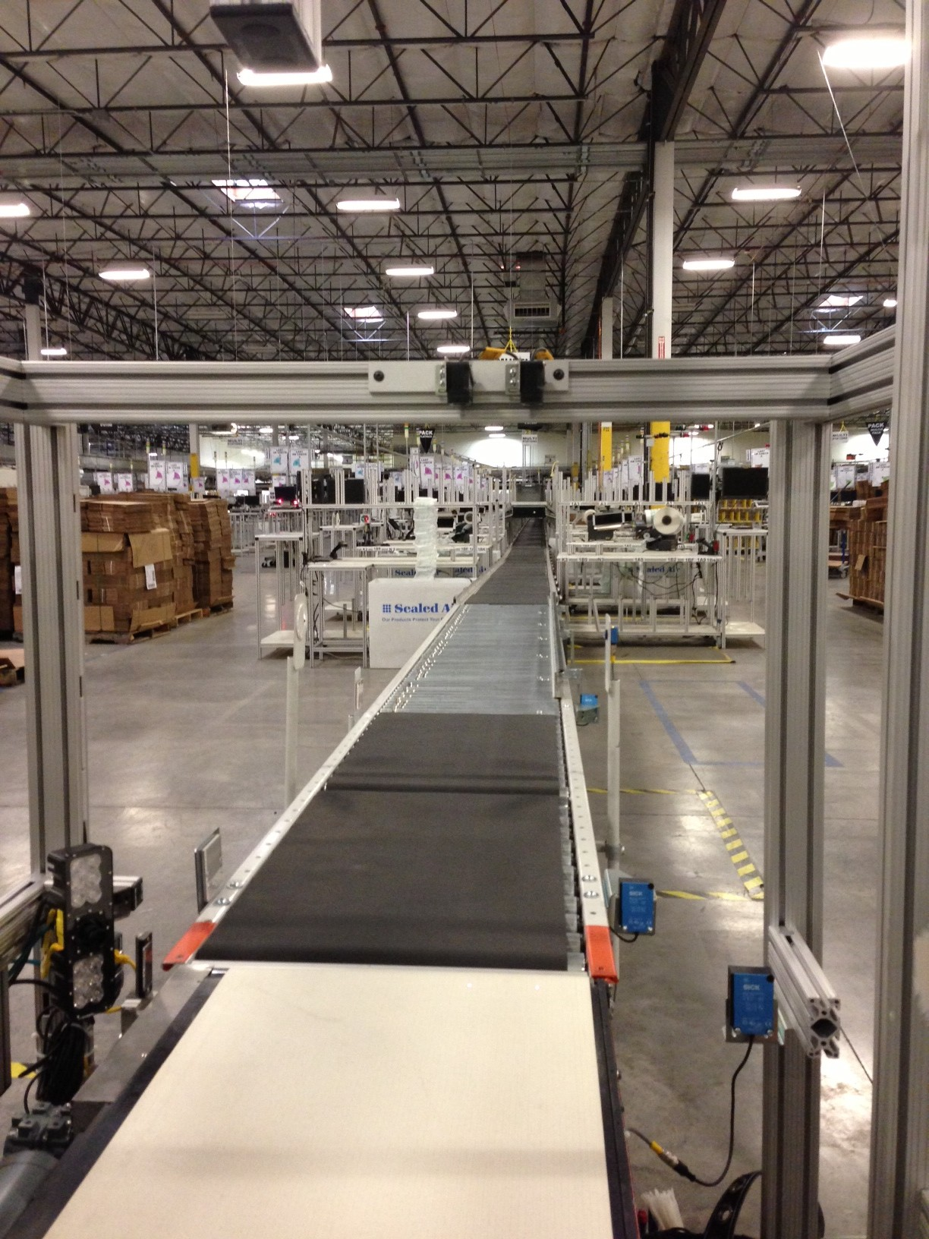

Figure 6 – System of sensors used for profiling

## Keyence Measuring Sensor Hardware Part List

|  |  |  |  |
| --- | --- | --- | --- |
| **MFG Part No.** | **Part Description** | **Qty.** | **Units** |
| IL-600 | Multi-Function CMOS Laser Sensor 600mm Range Sensor Head | 2 | Ea |
| OP-87057 | Multi-Purpose CCD Laser Micrometer IG Sensor Head Cable, 5m | 2 | Ea |
| IL-1000 | Multi-Function CMOS Laser Sensor DIN Rail Mounting Main Unit | 1 | Ea |
| IL-1050 | Multi-Function CMOS Laser Sensor DIN Rail Mount Sub Unit | 1 | Ea |
| DL-EP1 | Ethernet IP Connection Unit (Communication Unit) | 1 | Ea |

The two Keyence IL-600 sensor heads have a measurement range from 200mm (7.84”) to 1000mm (39.37”) from the sensor face. They are connected to amplifier units using the provided sensor cables (OP-87057). The amplifier units are used to configure and view the status of the sensors.

One sensor is connected to the main amplifier unit, the IL-1000. The second sensor is connected to the IL-1050 sub unit. The two amplifier modules are functionally identical with the exception that the main unit is wired to the power source and provides power to any connected unit. The units are DIN rail mounted and connect to a common power and communication bus via connectors located on the sides of the amplifiers. Settings are retained in the amplifier unit negating the need to re-program the settings if one of the IL-600 sensor heads is replaced.

The Slam Controller communicates with the sensor array using the DL-EP1 Module. The DL-EP1 is an Ethernet/IP enabled communications module. The DL-EP1 is also DIN rail mounted and connects to the same common power and communications bus that is used by the amplifier units via the connector on the side of the unit.

24 volt DC power is provided to the main unit via the integrated I/O cable, and is distributed through the bus to the IL-1050 amplifier and DL-EP1 Ethernet/IP module.

The PLC is configured to read data from the sensors via the Ethernet/IP interface. The DL-EP1 is connected to the Amazon network by a patch cable from the DL-EP1 to an Amazon provided RJ-45 data port jack.

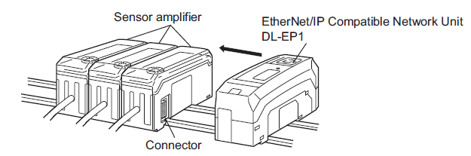

Figure 7 – Assembly Diagram from Keyence Publication DL-EP1_UM_96140E_E_1031-1

## Electrical Installation

Electrical installation of the Keyence hardware requires providing 24 VDC power to the IL-1000 Main amplifier unit. This unit distributes power to the IL-1050 amplifier sub unit, and DL-EP1 Ethernet/IP communications model through their common bus. The IL-1000 and IL-1050 are connected to the IL-600 sensor heads with the provided OP-87057 cables.

Power for the IL-1000 is sourced from the 24 VDC power supply in the Cognex enclosure located at the Scale Reader Station. The *Brown* wire in the IL-1000 I/O cable is connected to the 24 VDC terminal and the *Blue* wire is connected to the 0V terminal of the power supply. All other wires in the IL-1000’s cable and all wires in the IL-1050’s cable are unused. The unused wires shall be capped and installed in a neat workmanlike manner that will prevent the wires from contacting any conductive surface or components.

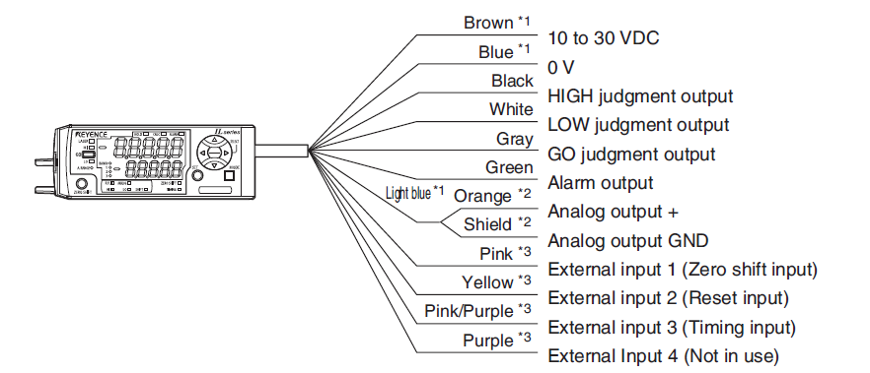

Figure 8 - I/O Cable Diagram from Keyence Publication IL_UM_235GB_235017_E_1092-2

## Reader Station - Cognex Vision System

## Overview

The purpose of this section is to outline the Cognex Reader assemblies (Reader Station) designed and provided by Cognex for final integration and assembly by Vendor. The Reader Station assemblies **can be** ordered through Cognex, who pre-builds the assemblies prior to shipping to Vendor for final assembly/integration into a SLAM. We invite vendors to use their own designs for the frame, as long as the station meets the functional 5-sided (NA), 6-sided (EU) scanning requirement.

The reader assemblies are camera-based units equipped with Cognex proprietary decode algorithms, which provide a cost-effective solution for omnidirectional reading and 2D decoding, as well as the ability to connect over Ethernet/IP, allowing the Readers to be fully integrated into the SLAM PLC architecture.

To avoid confusion and distinguish the Cognex Readers from camera-based, inspection systems, and laser scanners, the Congex Readers will be referred to as “Readers” throughout this document.

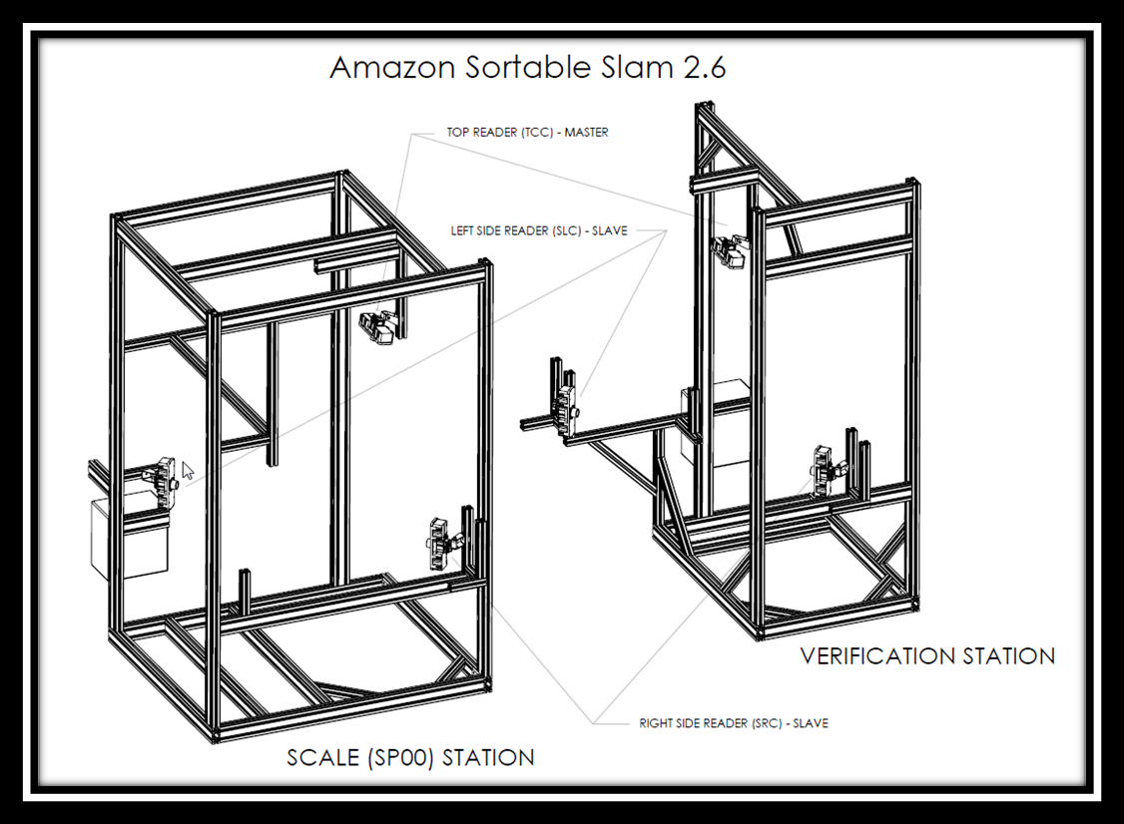

Figure 9 - G2.6 Reader Assembly (NA)

Two (2) Reader Station assemblies are to be provided. **We do however invite vendors to use their own designs for the frame, as long as the station meets the functional scanning requirement.**

## Scale Reader Station

The Scale Reader Station is located at the Scale Conveyor, in where the barcodes are read from the five visible sides of a package (and bottom in EU), while the package is being weighed. The weight data is married to the results of the barcode read, and transmitted to the SLAM PLC by the Scale Reader Station Master Reader.

## Verification Reader Station

The Verification Reader Station is located downstream of the last Print-and-Apply label station. This station reads both the SP00 label and the shipping label applied to the package. The results from the verification station are transmitted to the SLAM PLC by the Verification Reader Station Master Reader.

The Cognex Reader Stations only provide the appropriate data, formatted in the correct sequence, and are comprised of the same reader topology. Since the label can be either on the top, left, right, front or rear side of the package, each station consists of three DataMan 303X (DM303X) readers. One of the three readers is located across the top of the conveyor, the second and third are located on the leading and lagging corners of the scale conveyor. The reading sequence is initiated by a hardwire trigger from the SLAM PLC.

For NA designs, do not use the optional Power and I/O panel option for these stations. Power and I/O to be routed from the main control panel. A junction box option, from Cognex, replaces the previous power panel. There shall be no voltage above 50 volts in these cabinets. All 24VDC power to be sourced from main control cabinet.

For EU designs, Cognex Delux I/O and Single I/O boxes will be supplied as part of the Cognex BoM, for wiring/power requirements please contact Cognex.

## Hardware

For the Sortable SLAM two (2) Reader Station assemblies are required, Scale and Verify. It is the responsibility of the vendor, to advise Amazon if the Cognex solution does not provide the required 5-sided coverage at the scale or top sided coverage at verify. Please refer to Appendix A for example **NA BOM**.

For **EU BoM’s** please reach out to Cognex quoting “SORT_SLAM_6_SIDE_VERIFIER_XPAND” reference for sortable SLAM’s and “NONSORT_SLAM_5_SIDE_VERIFIER_XPAND” for non-sortable SLAM’s.

## Electrical Installation (NA/US only)

In order to remain modular in design all Reader connections terminate in the Power and I/O panel (provided as part of the Reader Station). The Power and I/O panel is powered by an 110VAC convenience outlet.



Figure 10 – Cognex Wiring at Scale



Figure 11 - Cognex Wiring at Verify

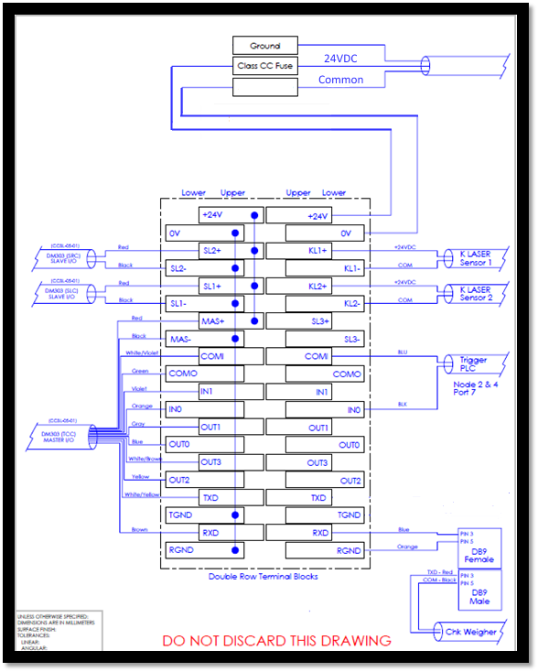

Figure 12 – Scale Scanners Power I/O panel from publication Amazon_Cognex_SLAM2_6_User_Manual_Rev00x

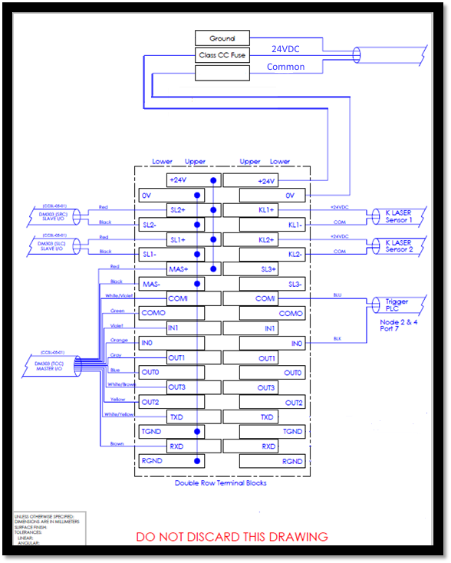

Figure 13 – Verify Scanners Power I/O panel from publication Amazon_Cognex_SLAM2_6_User_Manual_Rev00x

# 5 Field Wiring / Interface Signals

All components of the SLAM line (especially wires and cables) must be built such that the SLAM can be easily re-assembled at customer’s site. All wires and cables shall be labeled. Polarized connects should be used so that cables can be disconnected when the SLAM is separated for shipped, and easily re-connected when re-assembling the SLAM at a customer site with little technical skills.

To maintain consistency between SLAM builds and to support the above requirement, Sensor I/O and Interface Boxes (provided by Vendor) should be installed at the following locations:



**Downstream Interface Box**

**(Located under unit)**

**Upstream Interface Box**

Figure 14 – Field I/O Sensor and Interface Box Installation Locations

## 5.1 Field Device I/O Sensor Boxes

The Sensor I/O boxes should be an 8 Port M12 Phoenix SACB-8/16-L-C GG sensor block (part number 1698194, or an Amazon Controls Engineering approved equivalent,) wired to the main control panel using a Connector Hood cable assembly that is routed and terminated to the appropriate I/O modules within the main control panel.

Utilizing the Sensor I/O boxes permit all the field devices to be pre-wired and connected to a Sensor I/O box by a M12 connectors, while the Connector Hood cable assembly can be quickly and easily disconnected and reconnected during the teardown and re-assembly of the SLAM, thus leaving the field device wired and untouched.

## Field Sensor I/O Boxes Connection Detail

To be specified by vendor.

## Interface Boxes

Interface boxes should be comprised of a small junction box (or an Amazon Controls Engineering approved equivalent) of pre-wired terminal blocks that are wired back to the main control panel by a control cable. The terminals should be clearly marked, accessible for terminating external interlocks and troubleshooting.

The pre-wired junction boxes should be easily re-located during the teardown and re-assembly of the SLAM.

## Upstream Interface Box Detail

The following outlines terminal connections for the Upstream Interface Box:

|  |  |  |
| --- | --- | --- |
| **Terminal** | **Interlock Signal** | **Notes** |
| 1 | SLAM Main Control Panel | 24VDC |
| 2 | Upstream Estop Active Interlock | Dry contact from Upstream Estop circuit that is part of the SLAM Estop circuit |
| 3 | SLAM Running Interlock | Control power from Upstream control system |
| 4 | Upstream interlock control signal from “SLAM Running” dry contact interlock |
| 5 | SLAM E-Stop Interlock | Control power from Upstream E-Stop loop |
| 6 | Upstream E-Stop interlock control signal from “SLAM E-Stop” dry contact interlock |
| 8 | Upstream Running Interlock | Upstream conveyor running |
| 9 | Package Entering Interlock | Signal from Upstream system notifying that a package is entering SLAM (used to bring out of energy management) |
| 10 | Spare | Spare |

## Downstream Interface Box Detail

The following outlines terminal connections for the Downstream Interface Box:

|  |  |  |
| --- | --- | --- |
| **Terminal** | **Interlock Signal** | **Notes** |
| 1 | SLAM Main Control Panel | 24VDC |
| 2 | Downstream Estop Active Interlock | Control power from Downstream E-Stop circuit |
| 3 | Downstream E-Stop interlock control signal from Downstream E-Stop circuit |
| 4 | SLAM Running Interlock | Signal control power from Downstream control system |
| 5 | Downstream interlock control signal from “SLAM Running” dry contact interlock |
| 6 | Downstream Straight Takeaway Running  (“Flat Sorter Running”) | Dry contact signal to SLAM Controller indicating that the downstream Straight (either after the first or second divert) takeaway conveyors are ready to receive packages (typically conveyors that feed the flat sorter.) |
| 7 | Downstream Divert Takeaway Running  (“Shipping Sorter Running”) | Dry contact signal to SLAM Controller indicating that the downstream Divert (after the second divert) takeaway conveyors are ready to receive packages (typically conveyors that feed the shipping sorter.) |
| 8 | Spare | Spare |
| 9 | Spare | Spare |
| 10 | Spare | Spare |

## Printer Applicator Interface Signals

The following outlines the required interlock signals to/from the SLAM Controller (PLC) and the Label Applicator (LA):

| **From -> To** | **Signal Description (SIGNAL_NAME)** |
| --- | --- |
| **Between Print/Apply (LA) and SLAM PLC (SC)** | |
| LA1 -> SC | **Printer vacuum (Applicator 1 Vacuum)**  This signal indicates that Applicator 1 has a label attached to its tamp head, ready to apply. |
| LA1 -> SC | **Printer printing (Applicator 1 Printing)**  This signal indicates that Applicator 1 is processing data to generate a label. |
| LA1 -> SC | **Printer faulted (Applicator 1 Faulted)**  This signal indicates that Applicator 1 is in a fault (offline) condition. When this signal is asserted by the printer it indicates the printer is OK. When this signal is de-asserted (power lost), then the printer is in a fault condition. |
| LA1 -> SC | **Label low (Applicator 1 Label Low)**  This signal indicates that the pre-set label-low threshold has been reached at Applicator 1. |
| SC -> LA1 | **Apply label (Applicator 1 Apply Label)**  This signal is asserted by the SLAM Controller to trigger the tamp head to apply the label to the package. The signal is de-asserted when the "Applicator 1 Vacuum" signal is released by the applicator, indicating that the label has been applied. |
| LA2 -> SC | **Printer vacuum (Applicator 2 Vacuum)**  This signal indicates that Applicator 2 has a label attached to its tamp head, ready to apply. |
| LA2 -> SC | **Printer printing (Applicator 2 Printing)**  This signal indicates that Applicator 2 is processing data to generate a label. |
| LA2 -> SC | **Printer faulted (Applicator 2 Faulted)**  This signal indicates that Applicator 2 is in a fault (offline) condition. When this signal is asserted by the printer it indicates the printer is OK. When this signal is de-asserted (power lost), then the printer is in a fault condition. |
| LA2 -> SC | **Label low (Applicator Low Label)**  This signal indicates that the pre-set label-low threshold has been reached at Applicator 2. |
| SC -> LA2 | **Apply label (Applicator 2 Apply Label)**  This signal is asserted by the SLAM Controller to trigger the tamp head to apply the label to the package. The signal is de-asserted when the "Applicator 2 Vacuum" signal is released by the applicator, indicating that the label has been applied. |

## Scale Photo-eye Interface Signals

| **From -> To** | **Signal Description (SIGNAL_NAME)** |
| --- | --- |
| **Between Scale and PLC** | |
| Scale -> PLC | **No Package at end-PEC**  This is a signal from the scale to the PLC to indicate a package is at the end of the scale. Rather than add another PE at the end of the scale for the PLC, the scale just forwards the signal from the scale PE. |

# APPENDIX A: Cognex reader station BOM (NA/US sortable option)

Scale:

|  |  |  |  |  |
| --- | --- | --- | --- | --- |
| **Product ID** | **Product** | **Qty** | **Price Each** | **Extended Price** |
| DMR-303X-00 | DataMan 303X Fixed Mount ID Reader | 3 | Included | Included |
| DM300-HPIA-625W | High Powered Illumination Accessory | 3 | Included | Included |
| LEC-CFF16-F8 | 16 MM Lens | 3 | Included | Included |
| CCBL-05-01 | DM300 M12x12 Cable, 24v+IO+RS-232, 5.0m straight | 3 | Included | Included |
| DM500-CMTLC-000 | DataMan 300 Spare C-Mount Lens Cover | 3 | Included | Included |
| DM500-LNSEXT-000 | DataMan 300 Lens Cover Extension | 3 | Included | Included |
| CCB-M12x4MS-003 | DataMan 300 0.3M Jumper Cable | 3 | Included | Included |
| CCB-84901-1003-5 | Cognex Std. Ethernet Cable, 5M | 3 | Included | Included |
| DM100-PIVOTM-00 | DataMan 100/200/300 Pivot Mounting Bracket | 3 | Included | Included |
| DM300-PWR-BOX | Single Reader Power Box (OPTIONAL) | 1 | Included | Included |

Verify:

|  |  |  |  |  |
| --- | --- | --- | --- | --- |
| **Product ID** | **Product** | **Qty** | **Price Each** | **Extended Price** |
| DMR-303X-00 | DataMan 303X Fixed Mount ID Reader | 3 | Included | Included |
| DM300-HPIA-625W | High Powered Illumination Accessory | 3 | Included | Included |
| LEC-CFF16-F8 | 16 MM Lens | 3 | Included | Included |
| CCBL-05-01 | DM300 M12x12 Cable, 24v+IO+RS-232, 5.0m straight | 3 | Included | Included |
| DM500-CMTLC-000 | DataMan 300 Spare C-Mount Lens Cover | 3 | Included | Included |
| DM500-LNSEXT-000 | DataMan 300 Lens Cover Extension | 3 | Included | Included |
| CCB-M12x4MS-003 | DataMan 300 0.3M Jumper Cable | 3 | Included | Included |
| CCB-84901-1003-5 | Cognex Std. Ethernet Cable, 5M | 3 | Included | Included |
| DM100-PIVOTM-00 | DataMan 100/200/300 Pivot Mounting Bracket | 3 | Included | Included |
| DM300-PWR-BOX | Single Reader Power Box (OPTIONAL) | 1 | Included | Included |